SUPORT DE CURS

-LIMBA ENGLEZA-

NIVEL incepator-mediu

**Teacher: Andreea Ionel**

**References:**

**Websites:**

1. [www.englishexercises.org](http://www.englishexercises.org)
2. [www.kidshealth.org](http://www.kidshealth.org)
3. [www.kids.nationalgeographic.com](http://www.kids.nationalgeographic.com)
4. [www.allwildanimals.com](http://www.allwildanimals.com)
5. [www.english-for-students.com](http://www.english-for-students.com)
6. 6.
7. [www.english-for-students.com,](http://www.english-for-students.com,  www)
8. [www](http://www.english-for-students.com,  www).myenglishpages.com,
9. [www.basicplanet.com](http://www.basicplanet.com),
10. [www.speakenglish.co.uk](http://www.speakenglish.co.uk),
11. [www.grammar.net/idioms](http://www.grammar.net/idioms),
12. [www.english-at-home.com](http://www.english-at-home.com)

**Courses:**

1. Virginia Evans, ‘Successful Writing Intermediate’, Express Publishing
2. Jenny Dooley, Virginia Evans, ‘Grammar Way 1’, Express Publishing
3. Jenny Dooley, Virginia Evans, ‘Reading and Writing Targets 1’, Express Publishing
4. David Seymour, Maria Popova, ‘700 Classroom Activities’, Macmillan Books for Teachers
5. Jennifer Seidl, ‘Grammar One’, OUP
6. Ana Maria Marin, ‘Vocabulary Wizard-Apprentice’, Booklet
7. ‘Oxford word skills’ R. Gairns, S. Redman OUP;
8. ‘Grammar Spectrum 1’ Ken Paterson OUP;
9. ‘Sus Cortina pt viata’ S. Rotter, B. Sindelar UNATC;
10. ‘Engleza Intensiva’ V. Stancu, ed. Niculescu;
11. ‘Snapshot Elementary’ B. Abbs, I. Freebairn Longman;
12. ‘Headway Elementary’ L+J Soars OUP;
13. ‘Click on 1’ V. Evans Express Publishing;
14. ‘Just Vocabulary’ J. Harmer Marshall Cavendish;
15. ‘Going Green ’J. Elkington Ed. Penguin;
16. ‘Headway Preintermediate’ J+L soars OUP
17. ‘English Workbook’, Iulia Perju, Ed. Booklet 2014

**UNIT 1**

THE STAR OF THE DAY

LEAD-IN:

Where are you from?; Is it a beautiful place?; Who is your favourite famous person?

***READING:***

Before you read:

1. What do you think rock stars do every day?
2. How do they travel around?

**Bon Jovi** is one of the biggest rock bands in the world. The lead singer is Jon Bon Jovi who is an actor as well.

Jon usually gets up between nine and ten in the morning. He is not an early bird. ‘I’m not at my best first thing in the morning so I always have lots of coffee for breakfast’, says Jon. ‘I really need it’.

Jon likes to keep fit. ‘I go to the gym four mornings a week and do weightlifting. I also run for about half an hour in the evening’.

Jon has lunch at one o’ clock. He prefers ordinary Italian food or American food. He eats a lot of junk food and never diets.

The members of Bon Jovi rock band usually travel to and from their gigs in minibuses. The windows are dark so people can’t see them. ‘People always get excited when they see us and we don’t want any car accidents’.

At ten o’clock it’s time for Bon Jovi to get out on stage and start their show. Their concerts last about two hours.

After the show they usually go to a restaurant and relax. ‘We are always on a high after a gig, so we don’ go straight to bed!’

New words:

Gig = concert, spectacol (music)

To be at your best = a fi in forma

To diet (to be on a diet)= a tine dieta, regim

Weightlifting = haltere (sport)

To keep fit = a te mentine in forma

To be on a high = a fi agitat, a nu avea astampar

Comprehension questions:

1. Who is Jon Bon Jovi?
2. What’s his job?
3. Does he like waking up early in the morning?
4. How many diets is he on during a year?
5. What sports does he practise?
6. How often does he go to the gym?
7. How do they usually travel?

VOCABULARY PRACTICE

1. Match the countries to the nationalities.
2. France 1. Norwegian
3. Turkey 2. Irish
4. Spain 3. Polish
5. Poland 4. Dutch
6. England 5. Spanish
7. Finland 6. Greek
8. Norway 7. French
9. Greece 8. English
10. Holland 9. Turkish
11. Ireland 10. Finnish
12. Italy 11. Australian
13. Denmark 12. Japanese
14. Japan 13. Italian
15. Hungary 14. Danish
16. Australia 15. Hungarian
17. Portugal 16. Portuguese
18. Fill in the gaps with the correct nationalities.
19. The people who come from Madrid are…………………………..
20. The people who come from Dublin are………………………………..
21. Thor is from Helsinki. He is………………………………..
22. Hakan is from Ankara. He is………………………………….
23. Adam comes from London. He is…………………………….
24. Gianluca and Lucio are from Rome. They are……………..
25. **(PW ) Talk to your partner** about your nationality and the country you come from/are from/he comes from/is from. Use the names and countries in the above exercises.

**Ex**: Where are you from?/Where do you come from?/ What nationality are you?

1. ***Meeting People***. Read the dialogue and complete it with the following lines.

* Not much really.
* Oh, all right.
* Oh, I mean I only started last week. It’s my first job. What about you?
* That sounds interesting.
* Yeah, nice to meet you too.

**Angela**: Come on, Polly, there’s someone I’d like you to meet.

**Liz**: (a)………………………………………………………….

**Angela**: Dave, this is Liz. She’s in advertising too.

**Dave**: Oh, hi. Nice to meet you.

**Liz**: (b)……………………………………………………………..

**Dave**: And what do you do in advertising?

**Liz**: (c)……………………………………………………………

**Dave**: Sorry?

**Liz**: (d)…………………………………………………………….

**Dave**: Me? Oh, well, I’m working on a TV commercial for an internet bank at the moment.

**Liz**: (e)……………………………………………………………..

**Dave**: Yes, yes it is.

GRAMMAR PRACTICE

1. **(PW)** **Work with your partner**. Ask your partner if he/she likes doing these things. Answer with ***love, hate, enjoy, can’t stand.***

Ex: You: Do you like playing tennis?

Partner: Yes, I love playing tennis. OR No, I hate playing tennis.

1. Doing Math homework
2. Taking medicines
3. Buying clothes
4. Travelling
5. **‘Vienna Restaurant’**. Put the verbs in brackets into the present simple.

This restaurant is called ‘Vienna’. Ten people……………………….(work)here. Julia Thomas is the owner. She …………………………….(go) to the restaurant at four o’clock in the afternoon. The waiters ……………………………..(arrive)at half past four. They……………………(set) the tables and…………………………………(tidy) the kitchen. The chef, Pierre Rousseau,………………………(come) at five o’clock. He…………………………..(prepare) the food for the evening. The restaurant…………………………(open) at six o’clock. Many people……………………….(eat) here because the food is very good. The restaurant…………………………….(close) at one o’clock in the morning and at half past one Julia, the chef and the waiters ………………………….(go) home.

ACTIVITIES

**The Olympic Torch**

Imagine that the Olympic torch travels through as many countries as possible. Describe its journey from the city where the Games last took place to the new venue. (GW) Use the capitals of the countries as destinations.

E.g. A-A Greek athlete carries the torch to Istanbul.

B- A Turkish athlete carries it to Tehran.

C- An Iranian athlete carries it to………..

Get inspired from the flowing list of countries: Holland, the USA, Spain, Ireland, Japan, Finland, France, Italy, Germany, Russia, Hungary, China, Egypt, England, Greece.

* **Loan words**

Match the words with the languages they come from. (GW)

|  |  |
| --- | --- |
| **words** | **languages** |
| Anorak, tycoon, canoe, coach, bamboo, boss, lilac, silk, vodka, zebra, tomato, yoghurt, whisky, piano, pyjamas robot, kangaroo, mattress, mosquito, yacht, sauna, bizarre | Japanese, Eskimo, Carib, Hungarian, Farsi, Malay, Chinese, Swahili, Gaelic, Russian, Spanish, Dutch, Finnish, Aborigine, Basque, Italian, Arabic, Turkish, Hindi, Czech, Nahuatl, Dutch |

**Key:**

1. **Carib** language is a dialect spoken in the Republic of Suriname whose official language is Dutch
2. **Farsi** language is spoken in Iran ( limba persana)
3. **Swahili** language is the official language of Kenya
4. **Basque** language is a dialect spoken in the north-eastern Spain and the south-western France (the province is called Tara Bascilor)
5. **Aborigine** language is a dialect spoken in Australia
6. **Nahuatl** language is a language spoken in Central Mexico

MY MAGIC BOX

1. **Too Many Chiefs and Not Enough Indians** – this is often used to describe a company where there are too many managers and not enough people doing the actual work



1. **Beware of the Greek with a gift-** means that you must be suspicious of presents from certain people who are just looking for something from you.
2. **It’s all Greek to me** – we use this expression when we cannot understand something we read or hear
3. **Chinese Whispers** – this expression is often used as a metaphor for mistakes and inaccurate information which comes from rumours of gossip.
4. **Talk for England** – when someone can talk for hours and hours

**TASK: Following the model of the first idiom, draw your own images for the next ones.**

C:\Users\nuti\AppData\Local\Microsoft\Windows\Temporary Internet Files\Content.IE5\P37YI504\MC900434711[1].wmf

MY NAME IS………………………..

I AM………………..YEARS OLD.

I LEARN AT SCHOOL……………………………..; I AM IN THE …………………………TH GRADE.

I’VE GOT……………………..EYES AND……………………………HAIR.

I AM………………..METRES AND………CM IN HEIGHT.

MY HOBBIES ARE……………………………………………….

MY FAVOURITE SPORT IS………………………………………..

I LIKE LISTENING TO………………………………………………MUSIC.

I ADORE…………………………………….

I HATE……………………………………….

**FIND ME IF YOU CAN!!!!!**

C:\Users\nuti\AppData\Local\Microsoft\Windows\Temporary Internet Files\Content.IE5\IHRKZDSY\MC900088870[1].wmf

**HANDOUT 1/unit 1**

MEETING PEOPLE

1. In each box, **match the words** in the two columns to make statements or questions.

a. There’s someone

b. Paul, this is

c. I’d like you

d. Vic’s

e. Nice to

in advertising.

I’d like you to meet.

is Vic.

to meet Paul.

to meet you.

f. Are you

g. Do you like

h. How do you

i. What are you working on

j. What do

you do?

at the moment?

know our host?

what do you?

a friend of Vic’s?

k. Oh,

l. That

m. What a

coincidence! I’m an actor too.

really?

sounds interesting.

**HANDOUT 2/unit 1**

MEETING PEOPLE

1. Put the words in the correct order to make sentences. Write them in the correct place in the conversation.

* a/coincidence/./That’s
* teacher/be/you/a/?/young/bit/Aren’t/to/a
* a/ask/Can/?/I/question/you
* ?/Do/enjoy/studying/you/zoology
* him/I/like/./think/you’ll
* a/I’m/./teacher
* ,/./meet/nice/to/too/Yeah/you
* someone/I’d/like/meet/./to/There’s/you

**Sarah**: Come with me, Micky. (a)………………………………………………………………………

**Micky**: Oh, that sounds interesting.

**Sarah**: Yes, well (b)……………………………………………Joseph, this is Micky.

**Joseph**: Nice to meet you, Micky.

**Micky**: (c)………………………………………………………………………….

**Joseph**: What do you do?

**Micky:** I’m a zoology student.

**Joseph**: Oh, really. (d)…………………………………………………………………

**Micky:** I don’t really know. I’ve just got there. My course hasn’t started. But what about you? What do you do?

**Joseph**: (e)…………………………………………………………………

**Micky:** Oh, really. What do you teach?

**Joseph:** Zoology.

**Micky:** (f)………………………………………………………………………..

**Joe**: Yes, I suppose it is.

**Micky:** (g)…………………………………………………………………………

**Joe:** Of course.

**Micky:** (h)………………………………………………………………….

**Joe**: Yes, I suppose I am. But like you, I’ve just started.

1. Imagine you meet your favourite famous person in the street. You are one your way to the mall. Create a dialogue between you, your friend and the famous person, using the words and phrases in *Handouts 1and 2* and the following ones:

Hello, I don’t think we’ve met. I’m ...  
Pleased to meet you.  
Nice to meet you, too.  
May I introduce myself? My name is ...

Where are you from?/do you come from?

What nationality are you?  
Good morning, I’m ...  
How do you do?  
Can I introduce my friend? This is…………  
Hello, …….., this is……….

Famous people

1. Match the info in the chart and write sentences:

|  |  |  |  |
| --- | --- | --- | --- |
| **NAMES** | **COUNTRIES** | **NATIONALITIES** | **VERB** |
| Fernando Alonso and Rafael Nadal | Argentina | German | are |
| Kylie Minogue | France | Australian | is |
| Laura Pausini | Australia | American | is |
| Nicolas Sarkozy | The USA | Spanish | is |
| Angelina Jolie and Brad Pitt | Poland | Dutch | is |
| Ronaldo | Spain | French | are |
| Maradona and Messi | Italy | Polish | is |
| Vincent van Gogh | Germany | Italian | is |
| Angela Merkel | Holland | Brazilian | are |
| Marie Curie | Brazil | Argentinian | is |

Famous International symbols

1. What country is famous for…………………..?

|  |  |  |
| --- | --- | --- |
| **SYMBOL** | **COUNTRY** | **NATIONALITY** |
| bullfighting |  |  |
| spaghetti |  |  |
| windmills |  |  |
| Koala bears |  |  |
| waltz |  |  |
| hamburgers |  |  |
| vodka |  |  |
| Mount Olympus |  |  |
| The great wall |  |  |
| Rio carnival |  |  |

**HANDOUT 3/unit 1**

Present Simple practice

1. Complete the sentences with the correct form of the verb in brackets and ask questions to the underlined words.
2. She always…………………………………to school by bus. (travel)
3. They…………………………………………..home from college until 4.15. (not get)
4. He sometimes……………………………..to French classes on Mondays. (go)
5. Find someone who…..
6. Is exactly one month older than you are
7. Likes tea with lemon
8. Has a relative in the USA
9. Has 2 brothers and a sister
10. Gets up on weekdays before 7 o’clock
11. Goes shopping at the mall
12. Always helps in the house
13. Has a pet
14. Cooks
15. Is good at painting
16. Fill the blanks with the following words:

calls drink doesn’t spend

travels

don’t surf watches do

a. On Saturdays we ________do________ the shopping for the entire week.

b. John’s uncle always_______________________ TV in the evening.

c. He_____________________ his holiday at the seaside because he hates windy weather.

d. I know that they ______________________ the Internet for news , but for games.

e. Lara ______________________ to Italy in winter because it’s warmer.

f. Their little sister often_________________________ them for help.

g. Every morning we_______________________ a glass of milk or fresh juice.

4. Fill in with DO, DON’T, DOES, DOESN’T:

a. ___Do____ you like History? “No, I______________”

b. Jeremy works on a farm, but he ___________- work in the field.

c. They ___________________have classes in the evening because they study in the morning.

d. ”_____________ your brother play football?” “Of course, he ____________”

e. ”_____________ her parents live in the city?” “ No they ______________________”

f. ”_____________ Rebeca study French?” “No, she ____________________“

g. We ________________ like music, but we __________________ like jazz.

h. Her sister ___________________ go to this school because she lives in another town.

5. Ask the right questions for the given answers:

a) What’s your name?

Jenny Parker.

* _______________________________________________________________________?

In a village near London.

* _______________________________________________________________________?

Yes, a sister and two brothers.

* _______________________________________________________________________?

By school-bus.

* ________________________________________________________________________?

No, I hate long homework.

* _________________________________________________________________________?

Yes, I have a rabbit pet, Sammy.

1. Use the correct forms to fill in the interview with a young artist:

**Reporter**: Tell me about your music school, Leo!

**Leo**: ___________ I go______________ (I/go) to a music school in my home town.

**Reporter**: What subject _________________________ (you/ study) there?

**Leo**: _____________________ (I/study) the same subjects like in the other schools, but _____________________ (I/have) more classes of singing and playing the instrument.

**Reporter**: What ________________________ (you/like) best?

**Leo:** Of course, _____________________ (I/like) playing my guitar.

**Reporter**: __________________________ (you/like) singing?

**Leo**: No, in fact _______________________ (I/hate) it, but ______________________ (my teacher/say) that I need it.

**Reporter:**_________________________________ (you parents/like) your school?

**Leo**: ___________________________ (Mum/like) it, but ___________________________(my Dad/want) to change it.

**Reporter**: Why ____________________________(he /want) another school for you?

**Leo**: ____________________________(he/think) that _________________ (he/know) a better one

1. **Home Project.** Imagine you are a reporter for a famous magazine. Your boss wants you to interview a celebrity. Write the interview with that very well-known person. (where she/he Is from, his/her nationality, hobbies etc.)

**UNIT 2**

BRIDGING PEOPLE

Lead-in

‘A chaos of emotions’ – drama activity (page. 79)

Warm-up

Do you think the following quotes are true?

* *Friendship is one mind in two bodies.*
* *Your friend is the person who knows all about you, and still likes you.*
* *A real friend is one who walks in when the rest of the world walks out.*

READING

Read the following text, think of your best friend and describe him/her to your classmates.

Some friends come into our lives for just a short time. Others come and stay forever. Think about your closest friends. Are you old friends? Is he/she loyal to you? Does he/she like the company of others? Can you tell him/her a secret? Some people say that a family member is their best friend. Others say they have known their closest friends for many years. And some great friends haven't known each other all that long, but knew right away that there was a connection, or bond, between them. Could it be that there is a twin spirit out there for each of us?

What turns a stranger or acquaintance into a friend? Do you know right away if you are going to like someone? Some people think that any stranger can become a friend if they spend enough time together. That may be true for some people. But one thing most of us agree on is that true friendships seem to happen when people have something in common. Perhaps we see a part of ourselves in our friends. Maybe seeing the good in them helps us to see the good in us as well.

Jessie is my best friend. She lives next to me in a block of flats in the city centre. She is very attractive and she has something special that makes me like her a lot. She is a good-looking girl. Jessie is not tall, she’s got black hair and hazel eyes. She’s slim and very sporty. Her favourite sports are tennis and skating. When she smiles to you her bright smile gives you a hope to live. Jessie helps me whenever I need, advises me and makes me feel good as she is very optimistic and lively. Jessie is a talkative person, she likes talking to people and make new friends.

I am sure our friendship will last forever as we have a lot of things in common. It’s comforting to know you have a reliable friend who’s there for you no matter the weather or mood.

New words:

Acquaintance = cunostinta (persoana)

Bond =legatura

Twin spirit = suflet pereche

Hazel = caprui+verzui

Mood = chef, toana

Reliable = pe care te bazezi

Vocabulary practice

1. **Insert** the following adjectives in the right box:

Pessimistic, devoted, relaxed, scared, strong, ashamed, enjoyable, nervous, gorgeous, sick, guilty, lonely, silly, foolish, brave, calm, furious, shocked, surprised, afraid, shy

|  |  |
| --- | --- |
| **+** | **-** |
|  |  |
|  |  |
|  |  |
|  |  |

1. **Match** the adjectives with their opposites:

|  |  |
| --- | --- |
| Sick | Weak |
| Smart | Unlucky |
| Interesting | Stressed |
| Hard | Upset |
| Brave | Bad |
| Innocent | Angry |
| Calm | Boring |
| Strong | Silly |
| Happy | Pessimistic |
| Relaxed | Easy |
| Good | Guilty |
| Optimistic | Healthy |
| Lucky | Scared |

1. *The adjectives/expressions in the chart below describe friends/friendship. Find the definition for each one, then match them with their Romanian correspondent:

|  |  |  |
| --- | --- | --- |
| **Adjective** | **Definition** | **Romanian word** |
| loyal | Showing love, fondness, warmth | **A se intelege bine cu cineva, a avea o relatie buna** |
| sociable | Being understanding | **A fi prieten cu cineva chiar si in momente grele** |
| reliable | Very friendly with someone | **A pastra legatura cu cineva** |
| affectionate | Enjoying the company of others | **A te baza pe cineva care va face ce zice ca va face** |
| considerate | Someone who will do what he says he will do | **Caruia ii place compania altuia** |
| thick | Being a friend to someone even in difficult times | **Foarte bun prieten cu cineva** |
| Keep in touch | Feel sure that somebody will do what they say will do | **A fi intelegator** |
| Rely on somebody | Have a good relationship with someone | **A arata blandete, iubire** |
| Get on well with someone | Stay in contact with someone |  |

1. Give examples of people you know who can be described using one or more adjectives in the chart above and as many as you can from those on the cards given to you by the teacher.

Grammar

C:\Users\nuti\AppData\Local\Microsoft\Windows\Temporary Internet Files\Content.IE5\IHRKZDSY\MC900442036[1].wmfHow many friends have you got? Think of them and try to tell your classmates which one is closer to you.

|  |  |  |  |  |
| --- | --- | --- | --- | --- |
| **Adjective** | **Short adj** | **Long adj** | **Ended in -y** | **Irregular adj** |
| Positive | Tall | Wonderful | Happy | **Good /bad/little/many, much, a lot/far** |
| Comparative | Tall**er** than | **More** wonderful **than** | Happ**ier than** | Better /worse/less/more than/farther-further than |
| Superlative | **The** tall**est** | **The most** wonderful | **The** happ**iest** | The best/the worst/the least/the most/the farthest-the furthest |

Speaking Practice

**Pair work:**

Pick up 2 cards from the pile and talk to your partner about your friends. Compare them using the adjective on the cards you have just chosen.

Grammar Practice

**Activity 1:**

Write the comparative and superlative for the following adjectives:

1. Cheap………………………………………….
2. Old………………………………………………
3. Hungry………………………………………...
4. Sad………………………………………………
5. Careful………………………………………..
6. Famous………………………………………

**Activity 2:**

1. A.Fish/B. Fish/C. Fish/happy

  

1. Paul/Thomas/Larry/intelligent

Paul Thomas 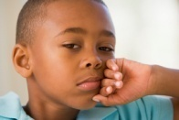Larry

1. John/Tim/Mike good at Maths

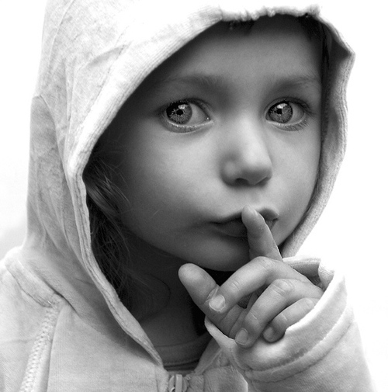John Tim Mike

1. Bike A/Bike B/Bike C; old

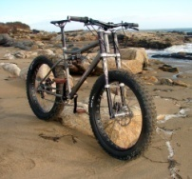A 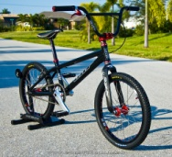B 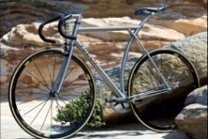C

**Activity 3**

Fill in the comparative form as in the example:

Ex: My motorbike ………(fast) yours. My motorbike is faster than yours.

1. Today it is ……….(cold) yesterday.
2. I need a …………….(big) bag ……………. this.
3. Travelling by train is……………………..(expensive) travelling by bus.
4. The last bus was…………………….(crowded) the first one.

**Activity 4**

Fill in the superlative form as in the example:

Ex: Sarah is……………………(young) person in my family.

1. Roses are the flowers which have ……………………..(nice) smell.
2. January is …………………..(cold) month of the year.
3. That is ……………….(funny) joke I’ve ever heard.
4. This is …………………….(bad)song I’ve ever heard.

**MY MAGIC BOX**

Read the following proverbs related to friends and find a correspondent in Romanian:

1.) Build bridges

2.) Cross someone’s path : a chance of meeting between two people.

3.) A friend in need is a friend indeed: When people are in need, true friends will always come to their aid.

4.) Friends in high places: Having friends in high places means someone knows people with power and influence. 5.) At odds with someone: People, facts and political parties can all be at odds when they are in a state of disagreement.

6.) Birds of a feather: As the saying goes, birds of a feather flock together. While opposites attract, similar people also get along well.

**Handout 1/unit 2**

C:\Users\nuti\AppData\Local\Microsoft\Windows\Temporary Internet Files\Content.IE5\IHRKZDSY\MC900442036[1].wmfWhen we want to say that two people or things are the same, we use **as…ADJ….as/not as…ADJ…as.**

1. Complete the sentences using as……as or than and the word in brackets.
2. This knife is…………………that one. (sharper)
3. Harry isn’t ……………………..I am. (strong)
4. This dictionary is…………………that one. (good)
5. Julie isn’t ……………………………..her cousin.(old)
6. Choose the correct answer:
7. My car was…………………than yours.
8. Expensive B. more expensive C. the most expensive

b. England is very………in winter.

A. cold B. colder C. the coldest

3. Correct the mistakes:

a. Chris is more cleverer than Scott.

b. A Fiat isn’t as more expensive as a Porsche.

c. The bus is longest than my car.

d. She is a very taller woman.

e. Jill is prettier from Sylvia.

4. Speaking activity**. Pair work.**

A friend of yours is visiting your city. He wants to stay at a nice hotel. Look at the pictures of the three hotels and make comparisons as in the example. Use the adjectives in the list.

Old, modern, big, small, a lot of, expensive, far

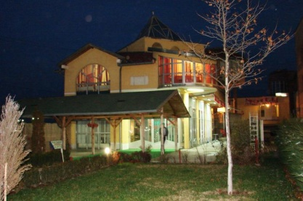Jumbo Hotel

Built in: 1930; Rooms: 30; Price: 25 pounds per night; Distance from city centre: 4 km.

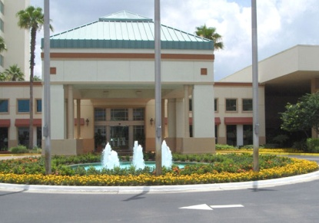Summer Breeze Hotel

Built in: 1820; Rooms: 60; Price: 40 pounds per night; Distance from city centre: 2 km

Sheraton Hotel

Built in: 1990; Rooms: 200; Price: 80 pounds per night; Distance from city centre: 1 km

UNIT 4

MY HOME IS MY CASTLE

Lead in

‘Mime the journey’-drama activity (improvisation)

Warm up

1. Do you live in a house or in a flat?
2. What is your favourite room in your house? Why?
3. If you had the chance to live somewhere else where would you like to live? Why?

Reading A

Read the following text and answer the questions:

My house is in a quiet area by the sea. It is not very big. It has eight rooms. There are three bedrooms, two bathrooms, two kitchens and a living room. The furniture in my room is simple but modern and comfortable. In my room there is a TV, a PC, a desk and a comfortable sofa and a table. There is a window above the table. The television is opposite my bed so I can watch it when I’m in bed. The wardrobe is on the left and my bed in on the right. The sea view from my room is fantastic. When the sun sets my rooms is invaded by the dark orange sun rays which reflect in the mirror on the other side of the room.

What is special about my house is the small garden with its trees and the oval swimming pool with colourful flowers all around it. I love being at home with my family.

1. Where is the house located?
2. How many rooms has it got?
3. Why is the TV placed opposite the bed?
4. What can you see from the window of the room?
5. Why does the child like being home with his family?

Reading B

1. Read the text .

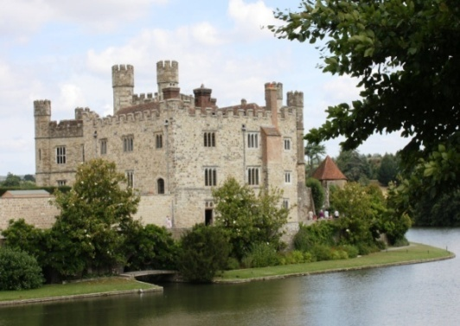

**My** name is Laureen. I am a princess, but not like **those** in fairy tales. I am a modern princess. My family lives in a castle by a lake. **Its** name is Deep Lake Castle. **This** area where our palace lies is not crowded and very hospitable. **Our** castle is different from the ones in stories. It is new, modern and very popular and spacious. The neighbourhood is great.

Outside the palace the atmosphere is peaceful and the front garden is heavenly. The lawn is green and there are loads of flowers. **These** flowers are my mother’s. **Her** flowers are always fresh and perfumed. My aunt, the countess, also has a great deal of plants, but **hers** are not that impressive. My grandfather, also a prince, is a very skilled man. **His** hobby is building terraces. The main terrace of our palace is his work.

My palace has 4 floors: the ground floor, 2 floors and a loft. Downstairs on the ground floor there is a hall where my dog has **its** kennel and where Joanna, one of our maids, always keeps her shopping bags. Then there is a corridor that leads to a roomy kitchen. The kitchen maids usually spend most of **their** time here, cooking delicious food for my family. **That** noise you can hear is coming from the living room which is next to the kitchen on the right. Here my parents invite state officials like the Prime Minister or their friends. I usually invite **mine** in my room. On the left there is a wooden closet where my parents keep their winter clothes. If you open that door over there you will find a lot of jars of jam and pickles because that is the pantry of the castle.

Upstairs on the first floor there are 2 bedrooms and 2 bathrooms. To go up to the second floor you need to use the wide staircase. There are 2 more bedrooms and 2 more bathrooms. Each floor has a dressing room and a balcony. The bedrooms overlook the back garden where the gardener takes care of the trees, bushes and flowers.

When my aunt comes to us for a long period of time, especially in the winter, she lives in the loft which is very cosy, bright and relaxing.

The newest part of our castle is the basement. Whenever someone in my family or our guests want to play a game or read a book in a quiet place they can go there, as we have both an enormous game room and a very neat and comfortable library there with soft armchairs and fluffy carpets on the floor.

(original text – prof. Andreea Ionel)

**2**. Complete the chart.

|  |  |  |  |
| --- | --- | --- | --- |
| **Rooms in the castle/Parts of the building** | **Adjectives describing places** | **Possessive adjectives and pronouns** | **Demonstratives** |
|  |  |  |  |
|  |  |  |  |
|  |  |  |  |
|  |  |  |  |
|  |  |  |  |
|  |  |  |  |
|  |  |  |  |
|  |  |  |  |
|  |  |  |  |
|  |  |  |  |

1. Answer the questions:
2. Where is the castle situated?
3. Whose flowers are they?
4. Whose hobby is building terraces?
5. Where is the dog’s kennel?
6. Who cooks delicious food?
7. Where is the living room?
8. What can we see in the pantry?

C:\Users\nuti\AppData\Local\Microsoft\Windows\Temporary Internet Files\Content.IE5\IHRKZDSY\MC900442036[1].wmf**Grammar**

* **Demonstratives**

**THIS – one object** near us **THAT-one object**

far from us

**THESE-more objects** **THOSE-**

near us **more objects** far from us

* **Possessive Pronouns and Possessive Adjectives**

|  |  |  |
| --- | --- | --- |
| **Object pronoun** | **Possessive adjectives** | **Possessive pronouns** |
| I | My | Mine |
| You | Your | Yours |
| He | His | His |
| She | Her | Hers |
| It | Its | Its |
| We | Our | Ours |
| You | Your | Yours |
| They | Their | Theirs |

**Activity 1**

* Put possessive adjectives and possessive pronouns in the gaps:

1. This car belongs to me. This is….......................car. It’s…………………… .
2. That ticket belongs to you. That is ……………………ticket. It’s …………………. .
3. These shoes belong to her. These are………………shoes. They are……………………. .
4. These cups belong to us. These are………………..cups. They’re ……………………….. .
5. That boat belongs to them. That is. …………………….boat. It’s ……………………… .
6. Those coats belong to us. Those are………………..coats. They’re ……………………… .
7. These photos belong to you. These are………………photos. They’re ……………………….. .
8. That watch belongs to him. That is…………………….watch. It’s……………………… .
9. This key belongs to her. That is………………………key. It’s ……………………… .

**Activity 2**

* Put this, that, these, those in the gaps in these dialogues:

1. Are you enjoying your meal?

Yes, thanks. ……………………fish is excellent.

1. This is my brother, Steve and ………………………are my sisters Kate and Gena.

Hello. I’ve heard a lot about you.

1. We’ve arrived! ………………..is our hotel here.

Can you see…………………..mountain? We’re going to ski there tomorrow.

1. ………………….exams last week were difficult.

Yes. I hope……………………exam today is easier.

1. ……………………..is your bed here.

But ……………………….beds there look more comfortable.

**Activity 3 - LISTENING:**

('Headway Elementary''; p.38; T. 28, Ed. OUP)



Listen to five people talking about where they live. Fill in the chart.

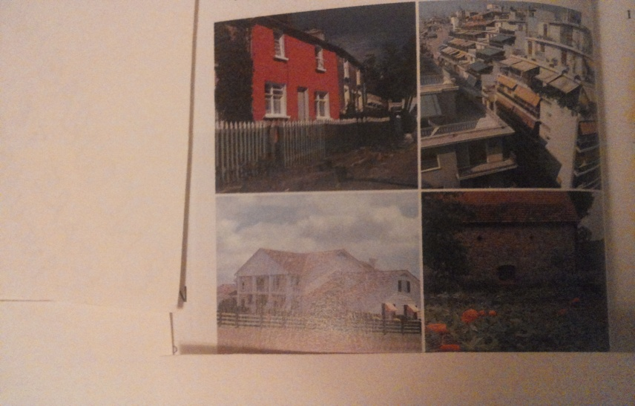

|  |  |  |  |  |
| --- | --- | --- | --- | --- |
|  | Anne Marie | Louis | Steve and Myra | Jason |
| House or flat? |  |  |  |  |
| Old or new? |  |  |  |  |
| Where ? |  |  |  |  |
| Number of bedrooms |  |  |  |  |
| Garden ? |  |  |  |  |
| Live(s) with? |  |  |  |  |

**Handout 1/Unit 4**

1. Speaking. Remember the listening activity in the lesson. Now you talk about where you live. Do you live in a house or in a flat? How many rooms are there? Do you have a garden? A terrace? What’s in your bedroom?
2. Writing. Write a paragraph about where you live.
3. Speaking. Look at the section of the house beneath. Imagine it’s 8.00 am and everyone is at home. Agree in which room/s they are and what they are doing. Think of your family. What do you think they are doing now?
4. Describe and Draw. Draw a plan of your home on the board and draw what the teacher tells you to. (Ex: There’s a table in the kitchen. There are some plants in the living room.) Now, in pairs, in your desks, do the same thing. Tell one another where 10 things are and see if they can draw them on your plan. After that ask each other questions about the places you live. (EX: Is there a table in the kitchen?)

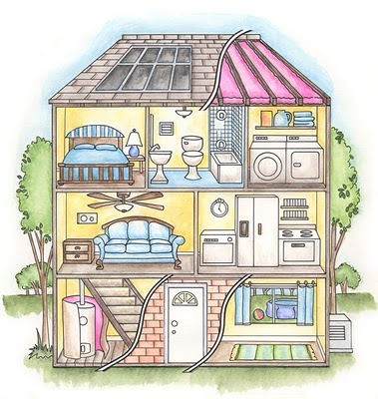

**Handout 2/Unit 4**

1. Speaking. Landscape gardens. (GW) The teacher describes her garden. On a large sheet of paper draw what you hear. The front of the garden is at the bottom of the page, the back is at the top of it.

Listen and put the things where the teacher tells you. (trees, kennel, greenhouse, fence, swing, path, shed, duck pond, flower bed, gate, hammock)

Word bank: kennel=cusca de caine; greenhouse=sera; swing=leagan; flower bed=strat de flori; hammock=hamac; path=poteca; shed=sura, sopron)

1. Fill in the speech bubbles with this, that, these or those and one of the words from the list:

Flowers, clock, man, cake, shoes, car.

Bubble 1:…………………. Bubble 4………………………..

Bubble 2:………………... Bubble 5………………………..

Bubble 3:…………………….. Bubble 6……………………….

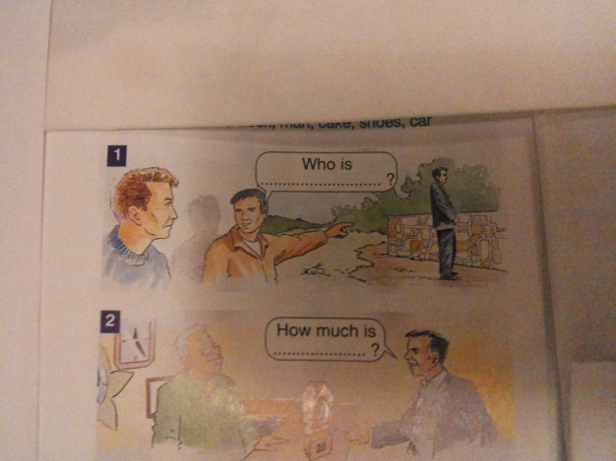 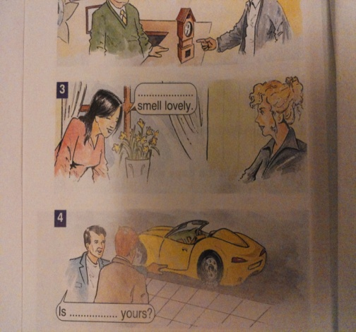 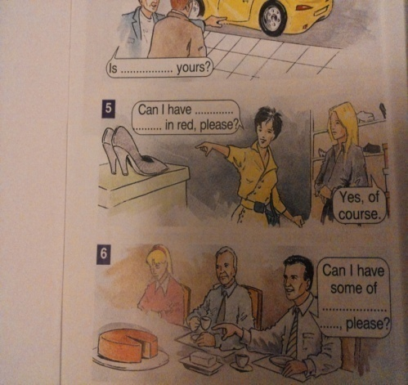

**3.** **Replace** the words in brackets with possessive pronouns (mine, yours…)

1. My car is faster than (your car). ……………………………..
2. Her house is bigger than (my house). ……………………………….
3. Your watch is more expensive than (his watch). ……………………………….
4. Their garden is more beautiful than (our garden). ……………………………….
5. Your son is younger than (her son). ……………………………….
6. Her job is more difficult than (his job). ………………………………..
7. My husband is stronger than (your husband). ………………………………..

House idioms

1. **have a skeleton in the cupboard / in the closet** = have an unpleasant secret
2. **be on the house** = be free (in a restaurant)
3. **safe as houses** = very safe
4. **get on like a house on fire** = get on very well with someone
5. **give house room to** = give space in your house to something
6. **be home and dry** = succeed at something and not expect any further problems

UNIT 5

LET’S DINE TOGETHER!

LEAD-IN

Do you enjoy going to parties?, What do you usually eat when you are at a party?

Imagine you are on holiday and you are visiting some foreign countries. Do you know how to say ‘Pofta Buna!’ in the language of the country you stop in?

|  |  |
| --- | --- |
| **Language** | [**Bon appetit**](http://www.omniglot.com/soundfiles/english/bonappetit_en.mp3) **/** [**Enjoy your meal**](http://www.omniglot.com/soundfiles/english/enjoyyourmeal_en.mp3) |
| [Afrikaans](http://www.omniglot.com/language/phrases/afrikaans.php) | [Smaaklike ete!](http://www.omniglot.com/soundfiles/afrikaans/bonappetit1_af.mp3) [Lekker eet!](http://www.omniglot.com/soundfiles/afrikaans/bonappetit2_af.mp3) |
| [Albanian](http://www.omniglot.com/language/phrases/albanian.php) | T'boftë mire! |
| Aromanian | Oraxi bunã! S-vã facã ghini! |
| [Basque](http://www.omniglot.com/language/phrases/basque.php) | [On egin!](http://www.omniglot.com/soundfiles/basque/bonappetit_eu.mp3) |
| [Danish](http://www.omniglot.com/language/phrases/danish.php) | [Velbekomme!](http://www.omniglot.com/soundfiles/danish/bonappetit_dk.mp3) |
| [Dutch](http://www.omniglot.com/language/phrases/dutch.php) | Smakelijk! [Smakelijk eten!](http://www.omniglot.com/soundfiles/dutch/bonappetit1_nl.mp3)[Eet Smakelijk!](http://www.omniglot.com/soundfiles/dutch/bonappetit2_nl.mp3) |
| English | Bon appetit! Enjoy your meal! (frm) Enjoy! Tuck in! Get stuck in! Eat already! (inf/slang) Happy eating! Get your laughing gear round this! (inf/slang) |
| [Finnish](http://www.omniglot.com/language/phrases/finnish.php) | [Hyvää ruokahalua!](http://www.omniglot.com/soundfiles/finnish/bonappetit_fi.mp3) |
| [French](http://www.omniglot.com/language/phrases/french.php) | [Bon appétit !](http://www.omniglot.com/soundfiles/bonappetit/bonappetit_fr.mp3) |
| [German](http://www.omniglot.com/language/phrases/german.php) | [Guten Appetit!](http://www.omniglot.com/soundfiles/bonappetit/bonappetit_de.mp3)[Mahlzeit!](http://www.omniglot.com/soundfiles/bonappetit/bonappetit2_de.mp3) |
| [Greek (Modern)](http://www.omniglot.com/language/phrases/greek.php) | (Kalí óreksi!) |
| [Hebrew](http://www.omniglot.com/language/phrases/hebrew.php) | (be'te-avon) |
| [Portuguese](http://www.omniglot.com/language/phrases/portuguese.php) | [Bom apetite!](http://www.omniglot.com/soundfiles/portuguese_br/bonappetit_pt-br.mp3) |
| [Scottish Gaelic](http://www.omniglot.com/language/phrases/gaelic.php) | Ith gu leòir! Ith do shàth! Làmh fhada is cead a sìneadh! |
| [Spanish](http://www.omniglot.com/language/phrases/spanish.php) | [¡Buen provecho!](http://www.omniglot.com/soundfiles/bonappetit/bonappetit_es.mp3)[¡Buen apetito!](http://www.omniglot.com/soundfiles/bonappetit/bonappetit2_es.mp3) ¡Que aproveche! |
| [Welsh](http://www.omniglot.com/language/phrases/welsh.php) | [Mwynhewch eich bwyd!](http://www.omniglot.com/soundfiles/welsh/bonappetit_cy.mp3) |

READING

Read the following text about food around the world and discuss about the types of food you like most.

[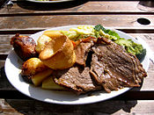](http://en.wikipedia.org/wiki/File:Sunday_roast_-_roast_beef_1.jpg) An English Sunday roast with roast beef, roast potatoes, vegetables and Yorkshire pudding.

[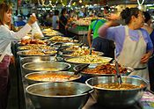](http://en.wikipedia.org/wiki/File:Thai_market_food_01.jpg) A market stall at Thanin market in Thailand selling ready cooked food

[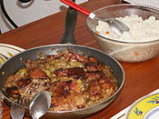](http://en.wikipedia.org/wiki/File:Yassapoulet.JPG) Yassa is a popular dish throughout West Africa, prepared with chicken or fish.

A cuisine is a characteristic style of cooking practices and traditions, often associated with a specific region, country or culture. To become a global cuisine, a local, regional or national cuisine must spread around the world; it's food served world-wide.

* African cuisine – the various cuisines of Africa use a combination of locally available fruits, cereal, grains and vegetables, as well as milk and meat products. In some parts of the continent, the traditional diet contains of milk, curd and whey products. In much of tropical Africa, however, cow's milk is rare and cannot be produced locally (owing to various diseases that affect livestock).

Curd= lapte batut

Whey= zer

* Asian cuisine - Ingredients common to many cultures in the east and Southeast regions of the continent include rice, ginger, garlic, sesame seeds, chilies, dried onions, soy, and tofu. Basmati rice is popular in the subcontinent, Jasmine is often found across the southeast. Curry is also a common dish found in southern and eastern Asia. Those curry dishes with origins in India and other South Asian countries usually have a yoghurt base.
* Bobotie **-** (South African) This popular meal is made of minced lamb or beef; bread, rice or potatoes, onions, and spices. The ingredients are mixed with egg and milk and baked.
* dim sum **-** (Chinese) This meal is usually eaten as breakfast or lunch at a restaurant. It’s noodles, dumplings, vegetables, and meat. Diners are served bite-sized portions in small bamboo cups.
* Samosas **-** (Indian) These snacks are made of meat, potatoes, vegetables, and spices stuffed inside pastry dough and fried in oil.
* Stink bugs: These little crawlies are of economic importance in Mexico and not least because they are eaten as taco filling, in Taxco and other regions of Mexico. The Mexican comestible bugs are called jumil, and are eaten alive.
* Gibnut with rice: The Gibnut, also known as Paca, is a nocturnal rodent that feeds on fruit and leaves. This animal is served on the side with rice, or in a stew.
* Stinkheads: A dish native to the Yup’ik Eskimos, stinkheads are basically fish heads (traditionally salmon) that has been buried in the ground throughout summer.

GRAMMAR PRACTICE

1. Look back at the text and underline the countable nouns with a line and the uncountable ones with 2 lines.
2. Pair Work.

[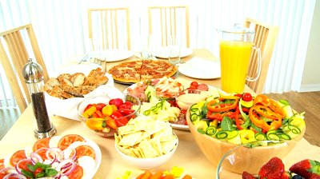](http://www.google.ro/url?sa=i&rct=j&q=&esrc=s&frm=1&source=images&cd=&cad=rja&docid=R_1mqn3iqU_0-M&tbnid=wr5GU484IYErVM:&ved=0CAUQjRw&url=http://tebasel.com/mag/2011/08/07/%D9%84%D9%85%D8%A7%D8%A6%D8%AF%D8%A9-%D8%B1%D8%B4%D9%8A%D9%82%D8%A9-%D9%81%D9%8A-%D8%B1%D9%85%D8%B6%D8%A7%D9%86/&ei=EZy-UsiiEYmX1AXqs4GQDw&bvm=bv.58187178,d.bGQ&psig=AFQjCNGjmKDGN6leUtOtdBYXz0Qfmv7NGw&ust=1388309754858976)

Look at this table. In pairs, ask and answer questions as in the example. Use *how much, how many, little/ a little, few/a few, no.*

Ex: A: How much butter is there on the table?

B: There is no butter.

1. Some uncountable nouns can be made countable by using the recipients (containers) they are put in: jar, bottle, piece, loaf, cup, bar, glass, kilo, carton, bowl, can, jug, slice, tin, packet, etc.

Ex:

[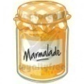](https://www.google.ro/imgres?imgurl=http://www.vectoredit.com/media/image/product/thumb_370_w/marmalade_l_001.jpg&imgrefurl=http://www.vectoredit.com/index.php?option=product&product_id=1260&docid=uxUCqxBnMMOYGM&tbnid=0QdmNMNjkIfl1M:&w=350&h=350&ei=H6C-UvjPK4-c0wW-gYHgDQ&ved=0CAIQxiAwAA&iact=c) [](https://www.google.ro/imgres?imgurl=http://img-new.cgtrader.com/items/20608/heineken_beer_bottle_3d_model_fbx_lwo_lw_lws_obj_max_lxo_79aea18d-613b-46ab-b323-2bc0c3a740dc.jpg&imgrefurl=http://www.cgtrader.com/3d-models/food/beverage/heineken-beer-bottle--2&docid=tB8I1aPPYA1-CM&tbnid=g6x24Gr_AvGcQM:&w=1024&h=768&ei=6KC-UqjHLuqf0QWmy4GoDw&ved=0CAIQxiAwAA&iact=c) [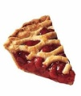](https://www.google.ro/imgres?imgurl=http://asliceofsanity.com/wp-content/uploads/2011/09/cherry-pie.jpg&imgrefurl=http://asliceofsanity.com/&docid=e7Zs3OZpNxbHFM&tbnid=HP28wgk5FTW9MM:&w=357&h=316&ei=HqG-UtOTNcHX0QX_r4HgDg&ved=0CAIQxiAwAA&iact=c) [](https://www.google.ro/imgres?imgurl=http://static3.depositphotos.com/1005647/205/i/950/depositphotos_2058598-Loaf-of-bread.jpg&imgrefurl=http://depositphotos.com/2058598/stock-photo-Loaf-of-bread.html&docid=-2UVJQCQIyjM-M&tbnid=UaiAsDvyO57QdM&w=1024&h=729&ei=jqG-UtuPBOqr0QWo7IHADg&ved=0CAQQxiAwAg&iact=c) [](https://www.google.ro/imgres?imgurl=http://www.favhdwallpapers.com/wp-content/uploads/2013/03/cup_of_coffee.jpg&imgrefurl=http://www.favhdwallpapers.com/a-cup-of-coffee-hd-wallpapers.html&docid=fwLLe0TLn-huWM&tbnid=G_gNc9dLdda1FM:&w=2560&h=1600&ei=3KG-UtPZIe6y0AWYn4CQAg&ved=0CAIQxiAwAA&iact=c)

a jar of marmalade a bottle of beer a piece of pie a loaf of bread a cup of coffee

[](https://www.google.ro/imgres?imgurl=http://www.insurancechat.co.za/wp-content/uploads/2012/04/cadbury-milk-chocolate.jpg&imgrefurl=http://www.insurancechat.co.za/2012-04/bicycle-thief-returns-bike-and-says-story-with-a-bar-of-chocolate/&docid=nttV_U2WjZEKIM&tbnid=UbjFq1k3mMtU7M:&w=440&h=390&ei=MqK-UtWeN6TX0QXo54D4DQ&ved=0CAIQxiAwAA&iact=c) [](https://www.google.ro/imgres?imgurl=http://www.savvyhousekeeping.com/wp-content/uploads/2012/03/dovesoap2.jpg&imgrefurl=http://www.savvyhousekeeping.com/turn-a-bar-of-dove-soap-into-liquid-hand-soap/&docid=oqSmF-QCTZGsIM&tbnid=S7OGXTx1JlPWyM:&w=504&h=412&ei=h6K-UsNC7pjQBcWUgCg&ved=0CAIQxiAwAA&iact=c) [](http://www.google.ro/imgres?biw=1280&bih=631&tbm=isch&tbnid=UmlKj19BIiJkhM:&imgrefurl=http://www.flickriver.com/photos/marinashemesh/popular-interesting/&docid=MbfjzWw72Y5mzM&imgurl=http://farm7.static.flickr.com/6102/6331771638_4bf2593829.jpg&w=1024&h=768&ei=z6K-UsOWMfTrygPRsYDQAw&zoom=1&ved=1t:3588,r:22,s:0,i:152&iact=rc&page=2&tbnh=187&tbnw=254&start=21&ndsp=28&tx=162&ty=72) [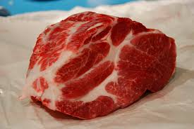](https://www.google.ro/imgres?imgurl=http://lh5.ggpht.com/_d6cI6368Y6U/SYi8GtASHfI/AAAAAAAADdI/9NB3dpV4-vc/s800/DSC_0034.JPG&imgrefurl=http://bricksnpavements.blogspot.com/2009/11/cut-big-piece-of-barbecued-pork.html&docid=3uhmWz3AbNroqM&tbnid=F0OBvrKoctBXhM:&w=800&h=535&ei=caO-Ur7IGKen0AX114GoDg&ved=0CAIQxiAwAA&iact=c)

A bar of chocolate a bar of soap a glass of milk a kilo of meat

[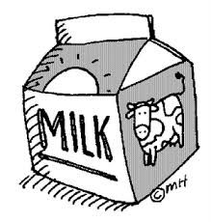](https://www.google.ro/imgres?imgurl=http://1.bp.blogspot.com/_oMC5aGCynCQ/STMzlL3f2MI/AAAAAAAAAAM/qEsvNadSA34/s320/milk.gif&imgrefurl=http://firstyearteacher08.blogspot.com/2008/11/how-to-open-milk-carton.html&docid=7ZShUEMJkC2e4M&tbnid=EYlkXqJ91ecDTM:&w=305&h=320&ei=_6O-UtTrI4aR0AWtqICADg&ved=0CAIQxiAwAA&iact=c) [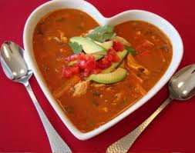](http://www.google.ro/imgres?biw=1280&bih=631&tbm=isch&tbnid=FbpGZgDmJ9515M:&imgrefurl=http://www.allvoices.com/contributed-news/6810597/image/63931417-a-bowl-of-love-soup&docid=EFqAxNwT9CS5qM&imgurl=http://img.allvoices.com/thumbs/event/609/480/63931417-bowl-love.jpg&w=609&h=480&ei=gaS-Ut2FCsb-ygOs8oDwDQ&zoom=1&ved=1t:3588,r:65,s:0,i:281&iact=rc&page=4&tbnh=187&tbnw=238&start=57&ndsp=22&tx=109&ty=105) [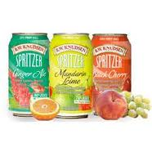](http://www.google.ro/imgres?biw=1280&bih=631&tbm=isch&tbnid=aem_up9vNX59QM:&imgrefurl=http://www.thisnext.com/item/F87A45FE/R-W-Knudsen-Family-Juices&docid=eBwHBqLlYQa9-M&imgurl=http://s9.thisnext.com/media/largest_dimension/CDC8C119.jpg&w=233&h=233&ei=gKW-UrORMOeNywP61IDIDg&zoom=1&ved=1t:3588,r:78,s:0,i:320&iact=rc&page=4&tbnh=186&tbnw=186&start=70&ndsp=23&tx=60&ty=113) [](https://www.google.ro/imgres?imgurl=http://image.shutterstock.com/display_pic_with_logo/188611/18861112215763651/stock-photo-jug-with-lemonade-17615914.jpg&imgrefurl=http://www.picstopin.com/300/jug-or-not-get-it-juggernaut/http:||drawception*com|pub|panels|2013|4-8|RSdgWW6GOz-10*png/&docid=dTs9lRBKNM1tKM&tbnid=U6bT2AjewbZIFM:&w=428&h=470&ei=26a-UoDMAYeW0AX_3IDYDQ&ved=0CAIQxiAwAA&iact=c)

A carton of milk a bowl of soup cans of juice a jug of juice

[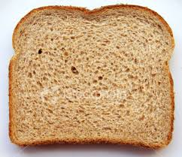](https://www.google.ro/imgres?imgurl=http://static.wix.com/media/a270cacd90b0a665e9e474023eb70d2a.wix_mp&imgrefurl=http://www.ign.com/boards/threads/the-poll-to-end-all-polls-which-is-better-with-bread-olive-oil-or-butter.452525439/page-2&docid=3-5MsgnTTDXXuM&tbnid=B-frYH8m3TpPmM:&w=380&h=328&ei=Zae-UvWbA8rB0QWVmoGYDg&ved=0CAIQxiAwAA&iact=c) [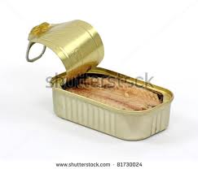](http://www.google.ro/imgres?biw=1280&bih=631&tbm=isch&tbnid=WimmY5cIK1lBGM:&imgrefurl=http://www.shutterstock.com/pic-81730024/stock-photo-the-top-of-a-tin-of-mackerel-opened-to-show-the-fish-on-a-white-background.html&docid=amyBZjbAW02HhM&imgurl=http://image.shutterstock.com/display_pic_with_logo/313771/313771,1311761088,4/stock-photo-the-top-of-a-tin-of-mackerel-opened-to-show-the-fish-on-a-white-background-81730024.jpg&w=450&h=385&ei=66e-Us_hGuPoygPdlYGwBA&zoom=1&ved=1t:3588,r:10,s:0,i:108&iact=rc&page=1&tbnh=161&tbnw=179&start=0&ndsp=16&tx=73&ty=73) [](https://www.google.ro/imgres?imgurl=http://im.ft-static.com/content/images/8c0afe40-7d79-11e1-bfa5-00144feab49a.img&imgrefurl=http://www.ft.com/cms/s/0/a4f92586-7d73-11e1-bfa5-00144feab49a.html&docid=cGLRvGBD6O8ocM&tbnid=-FA1UPzt_uvOBM&w=250&h=250&ei=wKm-UtyVJYWl0QXXhYHoDQ&ved=0CAkQxiAwBw&iact=c)

A slice of bread a tin of fish a packet of spaghetti

1. Match the words:

A glass of --------- chocolate

A slice of ---------- coke

A bar of ---------- bread

A tin of ----------- lemonade

A carton of ----------- beans

A piece of ---------- tea

A bottle of ----------- orange juice

A cup of ----------- cake

------------ coffee

------------- wine

------------- soap

* VOCABULARY PRACTICE

1. Find an appropriate ingredient for each kitchen action:

|  |  |
| --- | --- |
| **action** | **ingredient** |
| mix |  |
| add |  |
| stir |  |
| boil |  |
| fry |  |
| chop |  |
| slice |  |
| bake |  |
| blend |  |
| bread |  |
| roast |  |
| cut |  |
| dip |  |
| grate |  |
| grill |  |
| melt |  |
| pinch |  |
| pour |  |
| scramble |  |
| serve |  |
| simmer |  |
| spread |  |
| taste |  |
| shake |  |
| whisk |  |
| scrub |  |
| mash |  |
| peel |  |
| grind |  |
| mince |  |

**To mash=a zdrobi, a pasa**

**To simmer=a fierbe la foc mic**

**To dip=a inmuia**

**To grind=a rajni**

**To scramble=a bate ouale pt omleta**

**To bread=a face pane**

**To mince = a toca**

MY MAGIC BOX

* **to soup up =** make more powerful or stylish
* **to egg someone on =** urge someone to do something
* **to be nuts about something, someone =** like a lot
* **cool as a cucumber =** very relaxed
* **to butter someone up =** be extra nice to someone (usually for selfish reasons
* **(don't) cry over spilled milk =** get upset over something that has happened and cannot be changed
* **piece of cake** = very easy
* **to be the apple of someone’s eye =** to love someone very much

ACTIVITIES

* 1. Odd one out **(GW)**

Read the sets of four words carefully and choose the odd one out then explain why your decision.

* + 1. Lemon, grapefruit, grape, lime
    2. Fridge, cooker, microwave, toaster
    3. Indian, Chinese, French, Italian
    4. Cows, chicken, sheep, fish
    5. Bread, cake, pie, pudding
  1. Edible or Inedible? **(PW)**

Sit facing each other. Take turns to throw a ball of paper to your partner as you say a noun. When you catch the ball you must say immediately if the noun is edible (can be eaten) or inedible (cannot be eaten).

Ex:

A: Egg!

B: Edible. (throwing) – Book!

A: Inedible. (throwing) – House!

**HANDOUT 1**/unit 5

1. (PW) At the Grocer’s. Work in pairs. One of you is the grocer and the other is the customer. Read the example carefully and act out similar dialogues.

Ex: A: Hello, can I help you?

B: Yes, please. I need a kilo of strawberries and 2 kilos of carrots.

A: Anything else?

B: Yes. A carton of orange juice and 2 tins of beans.

A: Here you are.

B: Thank you.

*Shopping list*: onions, wine, olives, sausages, milk, butter, bananas, eggs, cheese, chocolate

1. **Speaking activity.** Read carefully through the menu below and discuss it with your partner. Tell him/her what your favourite dish is and why.

**[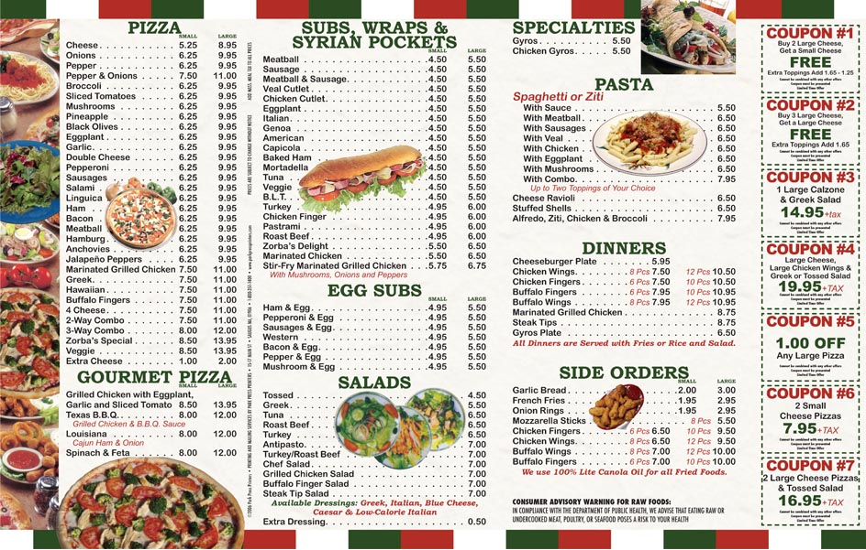](http://www.google.ro/url?sa=i&rct=j&q=&esrc=s&frm=1&source=images&cd=&cad=rja&docid=tgfqxecp05xpdM&tbnid=Mtttir38XIC_LM:&ved=0CAUQjRw&url=http://www.parkpressprinters.com/menutemplates.asp&ei=Ss6-UoeaKMXBswar5YAg&bvm=bv.58187178,d.bGQ&psig=AFQjCNGUj9ivwHXmAu_4Zy5cPd9k2oU2oA&ust=1388321596546733)**

* 1. Read this recipe for a chef’s salad and fill in the gaps with words from the list.

List of words: add, boil, cut, mix, pour, put, remove, serve, slice.

**Chef’s salad**

Ingredients

2 eggs, 8 lettuce (salata verde) leaves, 150 grams of cheese, 4 slices of ham, 1 small cucumber, 1 large tomato

Dressing

2 tablespoons (lingurite) of mayonnaise, 1 tablespoon of tomato ketchup, 1 tablespoon of vinegar, 1 tablespoon of olive oil, salt and pepper.

Instructions: ………………………………….the eggs for 10 minutes. ……………………..up the lettuce leaves and put them into a bowl. Cut the cheese and the ham into small pieces and add them to the bowl.

.......................................the cucumber and cut the tomato into pieces, then add them to the bowl.

…………………………………….the shell from the eggs, slice them and put them on top of the salad.

For the dressing: ……………………………..the mayonnaise, tomato ketchup, olive oil and vinegar into a small bowl and……………………………………..them well. ……………………..salt and pepper. Finally, ………………………..the dressing over the salad. ………………………with fresh bread.

**HANDOUT 2/unit 5**

1. You are having a party. Ten friends are coming. Write a shopping list for the party.

Shopping list

A kilo of grapes

------------------------------------------------------------------------------------------------------------------------------------------------------------------------------------------------------------------------------------------------------------------------------------------------------------------------------------------------------------

Don’t forget!!!

1. **Home Project**. Imagine you are a cook. Using the kitchen actions in Unit 2, the model on HANDOUT 1 and the quantifiers, write a recipe. You can either think of a real dish or make up an imaginary one.
2. Fill in the gaps using *some, any, no*.
   * 1. What would you like to eat? Eggs? Toast? Fruit?
     2. Could you give me……………………..toast, please?
        1. Would you like something to read?
        2. Yes. Could you give me…………magazines, please?
3. I’m going shopping. I’m going to buy…………………..bread.
4. Could you buy something for me, too? We haven’t got…………..milk. We also have……….eggs.

**4**. Write *much* or *many* in front of these nouns.

1. How……………………..money?
2. How…………………….films?
3. How…………………….snow?
4. How…………………….homework?
5. How ………………….times?
6. How…………………..food?
7. How……………………cats?

**UNIT 6**

IS IT FAR FROM HERE?

Lead in

‘The Magic Air’ – drama activity (improvisation) (page 66)

Warm up

1. I’m flying to Mars next week. Can you tell me, please, how I can get to this planet? Shall I turn right or left?
2. What is your favourite means of transport? Why?

Vocabulary

Study this list of phrases with your teacher.

|  |  |  |
| --- | --- | --- |
| Asking for directions | Giving directions | How far is it? |
| * excuse me, could you tell me how to get to …? (the bus station) | * it's this/that way | * how far is it to …? |
| * excuse me, do you know where the …………. is? | * you're going the wrong way | * how far is it to … from here? |
| * I’m afraid I don’t know | * you're going in the wrong direction | * is it far? |
| * sorry, I'm not from around here | * take this road | * is it a long way? |
| * I'm looking for …( address) | * go down there | * it's … |
| * are we on the right road for …? (name of a place) | * take the first on the left | not far |
| * is this the right way for …? (name of a place) | * take the second on the right | quite close |
|  | * turn right at the crossroads | quite a long way |
|  | * continue straight ahead for about a mile (1 mile=1.6 km) | a long way on foot |
|  | * continue past the fire station | a long way to walk |
|  | * you'll pass a supermarket on your left | about a mile from here |
|  | * keep going for another …( kilometer) |  |
|  | * go straight ahead |  |
|  | * go down this street |  |
|  | * it'll be … on your left, on your right, straight ahead of you… |  |
|  | * you can go there **by** bus/tram/train/   underground/foot |  |
|  | * it’s opposite the/next to/near/   between/in front of/behind |  |

|  |
| --- |
|  |
|  |

|  |
| --- |
|  |
|  |

|  |
| --- |
|  |
|  |

|  |
| --- |
|  |
|  |
|  |
|  |

|  |
| --- |
|  |
|  |
|  | |
|  | |

|  |
| --- |
|  |
|  |

|  |
| --- |
|  |
|  |

|  |
| --- |
|  |
|  |
|  |

|  |
| --- |
|  |
|  |
|  |
|  |
|  |

|  |  |  |  |  |
| --- | --- | --- | --- | --- |
|  | | | | |
|  | | | | |
|  | | | | |
|  | | | | |
|  | |  |  | |
|  | |

|  |
| --- |
|  |
|  |

|  |
| --- |
|  |
|  |

|  |
| --- |
|  |
|  |

|  |
| --- |
|  |

* Bahasa Indonesia
* Bahasa Melayu
* Čeština
* Dansk
* Deutsch
* Eesti
* English
* Español
* Français
* Italiano
* Latviešu
* Lietuvių
* Magyar
* Nederlands
* Norsk
* Polski
* Português
* Română
* Slovenčina
* Suomi
* Svenska
* Tiếng Việt
* Türkçe
* Български
* Русский
* Українська
* Ελληνικά
* 中文
* العربية
* हिन्दी
* 日本語
* 한국어
* ગુજરાતી
* ภาษาไทย



**Activity 1 – Speaking (PW)**

Look at the map below. Use the following words to :

* Tell how to get from the station to the hotel;
* Ask the way to the bank (and give directions);
* Tell how you can get from the bank to the chemist’s;

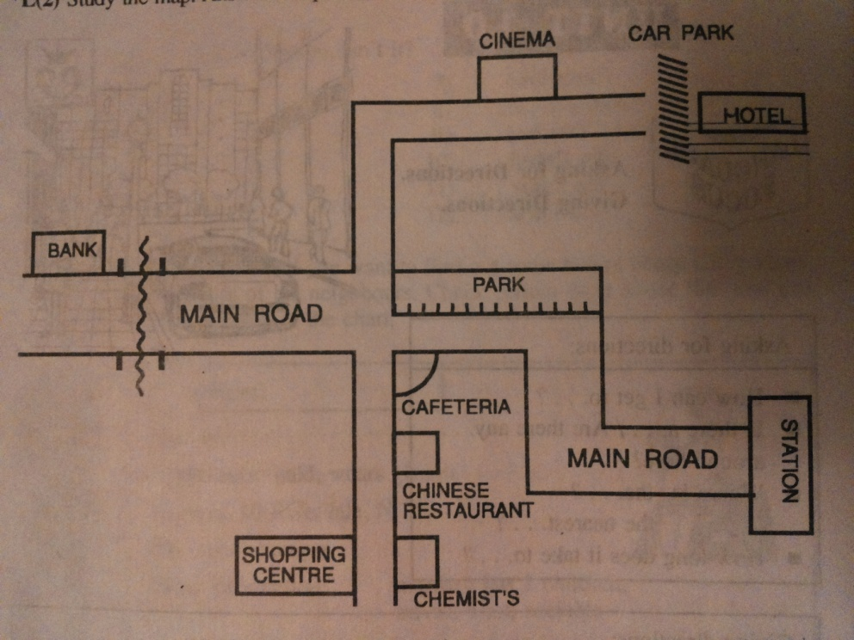

**Activity 2 – Speaking (PW) and Listening**

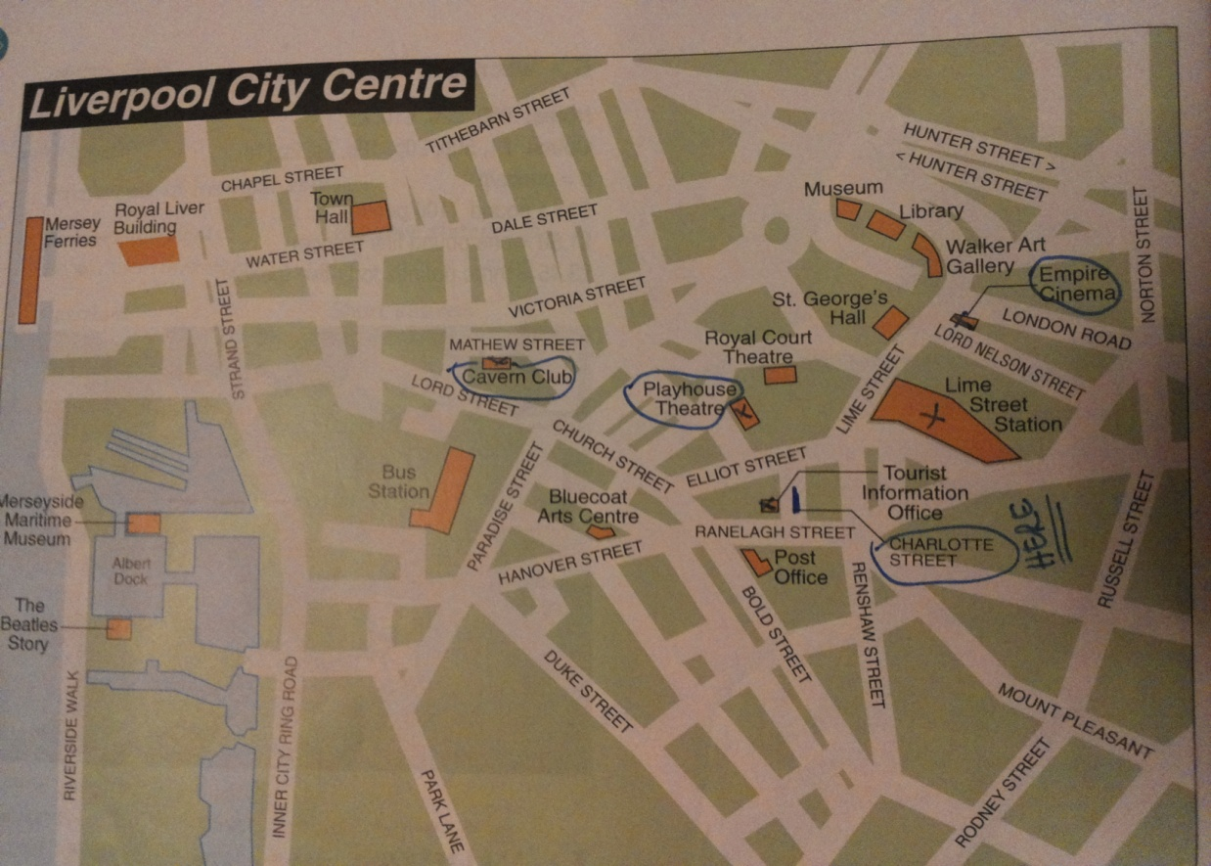

You are outside the Tourist Information Office in Charlotte Street. Use the map of the centre of Liverpool to ask for and give directions to:

* Lime Street Station
* The Empire Cinema
* The Playhouse Theatre
* The Cavern Club

**LISTENING - CD Snapshot/SB; Unit 8**

Listen to the dialogue and see if you were right.

Handout 1/Unit 6

**LISTENING - ("Headway Elementary", Unit 5, T. 29)**

1. Listen to the conversations and complete them:

**a.** A: Excuse me! Is …………………….a chemist’s………………..here?

B: Yes. It’s over……………… .

A: Thanks.

**b.**A: …………………….me! Is there a………………….club near here?

B: Yes. …………………. ………………………..Queen Street. Take the second………………… ……………………. ……………………right.

A: Thanks.

**c.** A: Excuse me! Is there a …………………near here?

B: There’s …………………..in Church Street……………….. ……………………..the bank and there’s one in Park Lane opposite the ……………….. …………………

A: Is that one…………………?

B: No. Just two minutes.

**d.**A: Is there a cinema near here?

B: ……………the first left and it’s ………………….. ……………………left, ……………………the flower shop.

A: Thanks a lot.

**2.Speaking** (PW): My neighbourhood

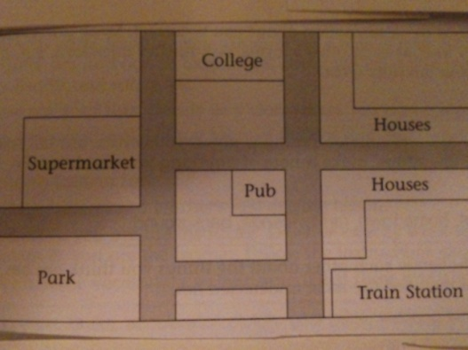 Give names to the streets. Then, in pairs, decide where to put these places: bakery, car park, café, bus stop, newsagent, restaurant, chemist, corner shop.

Handout 2/Unit 6

* 1. **Reading**: ‘Find the hidden map’

Read the text and study the underlined prepositions:

Walk **towards** the main road, until you get to the **edge** of the village. Then go **over** the bridge and turn left. There’s a lane that takes you through a farm and just **beyond** the farmhouse there’s a cottage. Go round to the rear of the cottage and you’ll see a small stream. Go across and **onto** the bank on the other side. You’ll see some bushes **beside** the stream. There’s a statue **among** the tall grasses and **underneath** the statue there’s a map. It’s hidden **beneath** a pile of leaves.

Towards = in the direction of;

Edge = the place where something ends;

Beyond = past a place and further away;

Rear = the back of something (car, building);

Onto = moving to or on a particular place;

Beside = next to, by;

Among = surrounded by things;

Underneath = under (when smth is hidden or covered);

Beneath = under;

Stream = parau;

Bushes = tufe

**2. Match** the prepositions in exercise 1 with the pictures:

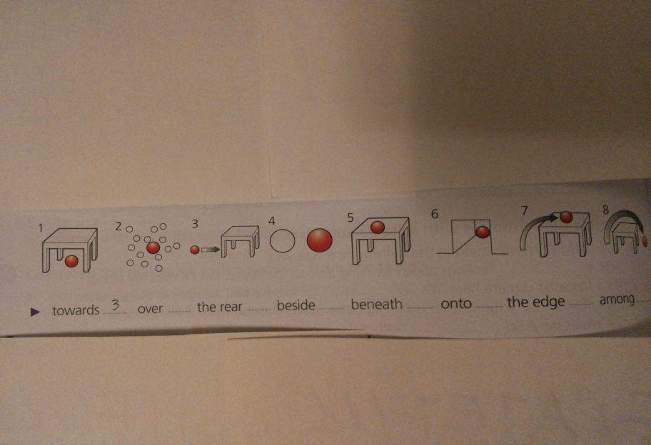

* 1. **Complete** the sentences with words from the list.
     1. The glass fell……………………the floor and smashed.
     2. I could see a few of my friends………………….the crowd.
     3. Don’t sit……………there. Come and sit…………………me.
     4. I’m not surprised I couldn’t find my pen; it was…………………..all those books.
     5. We didn’t stay in one town – we went all…………………the place.
     6. I couldn’t see the accident because I had my …………………..to the window.
     7. Don’t stand so close to the……………………of the road; it’s dangerous.
     8. There’s a village in the valley and ……………….it you can see the mountains in the distance.
     9. The front seats are great, but there isn’t much room (space) for your legs in the………….. .
  2. **LISTENING** Look at the pictures and listen to Robin talking about his driving lesson. Put a preposition from the list into each gap. **("Headway Elementary", T. 59a)**

|  |
| --- |
| Along down into out of over past through under up |

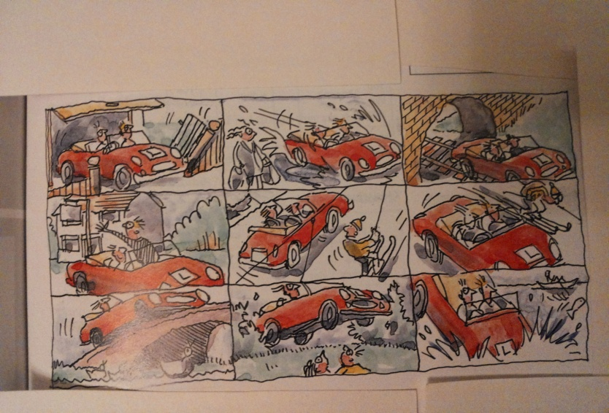

Robin drove Next he drove

……………………………the garage, ……………………………..the river,

…………………………..the road and ……………………………..the hedge(gard viu)

…………………………..the bridge. and………………………..the lake!!!!!

Then he drove

………………………….the pub,

…………………………..the hill and

…………………………..the hill.

**5.** Look at the words in the box. Divide them into four groups. Some of the words can be used more than once.

|  |
| --- |
| Driver pilot attendant land catch miss get on take off check in ticket fare station take platform boarding pass meter timetable gate |

|  |  |  |  |
| --- | --- | --- | --- |
| TRAIN | TAXI | BUS/COACH | PLANE |
|  |  |  |  |
|  |  |  |  |
|  |  |  |  |
|  |  |  |  |

**6. Complete** the gaps in these sentences with words from the table.

* + 1. If we don’t hurry up, we’ll…………………………the bus. It leaves the bus……………….at ten o’clock.
    2. It’s cheaper for four people to …………………..a taxi rather than go on the underground, because the taxi …………….comes to less than the price of four……………..
    3. After you …………………………your luggage, they give you a …………………………….which you take along to the…………………..., where someone checks it before you………………..the plane.
    4. The train to Edinburgh leaves from ………………………..number eight and you have to buy your…………………..in the office before you……………..
    5. In the ………………………….. it said that the bus left at 10.00 and so we got there at 9.45 so that we would be sure to………………it.

1. Look at the map. You have just finished playing crazy golf at the Putting Green and you have decided to walk to Beacon Cove. Complete the directions.

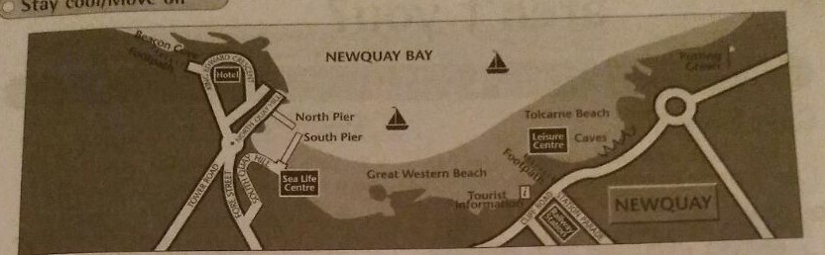

past along up down

from down until you get to

turn right into turn left

The quickest way to Beacon Cove is to go down to Tolcarne Beach. They walk_________________________ the beach. Go _________________________ the caves and keep walking_____________________________ the South Pier. Go ________________________South Quay Hill and ___________________ Fore Street. When you get to the roundabout, go straight on. You’ll see a big hotel in front of you. __________________ at the hotel.

There’s a footpath_____________________ the road ___________________________ to Beacon Cove.

1. Look at the map of Newquay again. You are at the Sea Life Centre. Give directions to 1)the North Pier by car and 2) the railway station on foot, via the beach. Write the conversations in you notebook using some of the prompts.

* Could you tell me the way to/where…..?
* Certainly. / Of corse.
* As far as
* On the right / left
* Until you get to
* Take the first turning.

**Conversation 1**

**Tourist: Excuse me, could you tell me the way to…?**

1. Circle and correct the mistakes.

He fell to the water. **He fell into the water.**

1.The football went through the window.

2.Walk along this street as far to the playing fields.

____________________________________________________________________________________________________________________________________________________________________________________________________

3.Two students, who looked out of the window at the time, saw the accident.

____________________________________________________________________________________________________________________________________________________________________________________________________

4.Excuse me. Could you tell me where is the station?

__________________________________________________________________________________________________________________________________________________________________________________________________________

**UNIT 7**

WE WORK TOGETHER AS A FAMILY

LEAD-IN

How many members are there in your family?; Do you think a larger family is also a happier one?

READING

The Robinsons have got a large family. They are happy together, even if sometimes they yet have fights, especially the little ones.

Mrs. Robinson is the mother of the family. She is very kind and friendly and laughs and smiles all the time. Everyone likes her. She owns a beauty salon in the city center. Rupert is her husband. He is a bit chubby, blue-eyed and has got a moustache. He is really vain and likes looking at himself in the mirror a lot. He is also cruel and likes upsetting people. He is a mechanic. Their daughter Rebecca is really lazy and hates doing any work. But she still has a job, she is a receptionist. She works in a modern and famous hotel. Rebecca’s cousin, Steve, is an insincere man and never says what he really thinks. Steve is ambitious and wants to be an assistant manager one day. Zeph, Mrs. Robinson’s nephew, is 20 years old and very much in love with Angela. He is tall and well-built. He’s got a round face and curly hair. He is a jealous person. He is really a bad-tempered man and can get angry very easily. He is a bricklayer. Rebecca is married. Her mother-in –law, Christine Carr, is a hard-working woman because she has to earn a lot of money for her family. She is an honest person and always says what she thinks. Rebecca’s godmother is the boss of a restaurant and she is very rude to her stuff. She is a mean woman and wants to save money all the time.

A very special person in this family is Mr. Garrett, Mrs. Robinson’s brother. He is a bit plump, in his sixties. Tom Garrett is bald and has got bushy eyebrows. He is a teacher of English and French and he is special because he lives in France, but he works in England. Only on Mondays he leaves home almost right after midnight and travels a lot by car and by ferry to Manor School in Kent. In England he teaches French and back home in France he teaches English.

* After reading the text, underline all the words related to family relationships with red, and all the jobs with green. After that, circle the words regarding people’s character and physical appearance.

VOCABULARY PRACTICE

1. **Fill in the chart** with word or phrases referring to both physical appearance and character of each person in the above text.

|  |  |
| --- | --- |
| **Physical appearance**-What does he/she look like? | **Character**-What is he/she like? |
|  |  |
|  |  |
|  |  |
|  |  |
|  |  |
|  |  |
|  |  |

**2. Match** each job with the activity it implies.

|  |  |
| --- | --- |
| **Job** | **Activity** |
| waiter | Translates things |
| doctor | Mends cars |
| bricklayer | Makes films |
| translator | Flies a plane |
| mechanic | Cuts hair |
| director | Looks after sick people |
| hairdresser | Works in a hotel |
| baker | Sells things |
| receptionist | Makes bread |
| pilot | Writes for a newspaper |
| journalist | Serves people food |
| vet | Builds and repairs walls |
| carpenter | Defends guilty people in the court of law |
| surgeon | Works in the garden |
| lawyer | Operates on sick people |
| gardener | Makes things out of wood |
| shop assistant | Takes care of sick animals |

1. Guess the members of the family:
2. My mother’s brother is my…………………………….
3. My uncle’s son is my…………………………………….
4. My father’s wife is my……………………………………….
5. My sister is my father’s…………………………………….
6. My mother’s daughter is my…………………………………
7. My father’s sister is my……………………………………….
8. My mother’s father is my……………………………………

**4. Complete** the chart then make sentences about your family members.

|  |
| --- |
| Fantastic sense of humour good-looking immature great sense of style outgoing olive skin  dark hair casual clothes friendly wavy hair pale complexion rude lazy pointed nose shoulder-length hair slim of medium height generous popular bossy attractive plump |

|  |  |
| --- | --- |
| **Appearance** | **Personal qualities** |
|  |  |
|  |  |
|  |  |

GRAMMAR PRACTICE

* + Jane and Corinne are good friends. However, there are some differences between their life styles.

Compare these two girls using ***has got***. (Pair Work)

[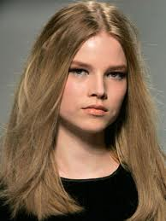](http://www.google.ro/imgres?biw=1280&bih=631&tbm=isch&tbnid=C4cw4rKhYt7qGM:&imgrefurl=http://www.marieclaire.com/hair-beauty/how-to/hair-summer-dry&docid=WsEbn27C-KrWNM&imgurl=http://www.marieclaire.com/cm/marieclaire/images/DF/summer-hair-medium-new.jpg&w=300&h=400&ei=IPy-Uur5N6nyyAONyoC4AQ&zoom=1&ved=1t:3588,r:31,s:0,i:179&iact=rc&page=2&tbnh=179&tbnw=133&start=22&ndsp=28&tx=78&ty=141) [](https://www.google.ro/imgres?imgurl=http://www.desktopas.com/files/2013/06/Women-Lips-Faces-Photomanipulations-Brown-Eyed-Girls-Black-Hair-1920x1200.jpg&imgrefurl=http://www.desktopas.com/women-lips-faces-photomanipulations-brown-eyed-girls-black-hair-19201200.html&docid=IJyhRzPzHBCvOM&tbnid=EW46D-KGy0wDqM:&w=1920&h=1200&ei=-Py-Uo2xCPLK0AXZ2YHwDQ&ved=0CAIQxiAwAA&iact=c)

Jane Parson /actress Corinne Dim/fashion model

[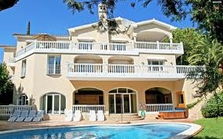](https://www.google.ro/imgres?imgurl=http://www.walldoze.com/images/full/2013/12/14/big-house-wallpaper-e-f-modern-for-desktop-houses-with-pools-really-nice-beach-big_house_wallpaper_e8f85.jpg&imgrefurl=http://www.walldoze.com/hd-wallpapers/big-house-wallpaper-e-f.html&docid=WMmjx_VjD-cAiM&tbnid=vt5Vwfg_bf1_3M:&w=2560&h=1600&ei=3v2-UonNI4_L0AXOroGoBw&ved=0CAIQxiAwAA&iact=c)a big house [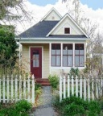](https://www.google.ro/imgres?imgurl=http://www.smallhousestyle.com/wp-content/uploads/2011/05/harbinger-510x572.jpg&imgrefurl=http://www.smallhousestyle.com/page/4/&docid=B8eO6MWcdJc5JM&tbnid=W-qGosaloBm69M:&w=510&h=572&ei=VP--UuLeIqm10QWbzoHIDw&ved=0CAIQxiAwAA&iact=c) a small house

[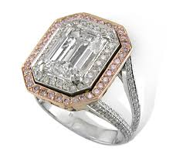](https://www.google.ro/imgres?imgurl=http://www.msdiamondandjewelry.com/Media/uploads/ST2326-14.jpg&imgrefurl=http://www.msdiamondandjewelry.com/&docid=1pfpgNc-KzHCGM&tbnid=NPufNYoJKYMJRM:&w=975&h=877&ei=QP6-Uo_-Ku_60gX6r4BA&ved=0CAIQxiAwAA&iact=c)many jewels [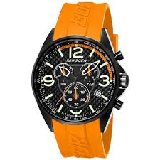](https://www.google.ro/imgres?imgurl=http://www.ticwatches.co.uk/images/t18305-t18-orange-chronograph-torgoen-watch-p26492-11949_zoom.jpg&imgrefurl=http://www.ticwatches.co.uk/t18305-t18-orange-chronograph-torgoen-watch-p26492&docid=EX3fo626n4j97M&tbnid=ryBVsbNwKoRiZM:&w=922&h=922&ei=6f--Uv7jNaOp0QW28oDAAw&ved=0CAIQxiAwAA&iact=c)a watch

[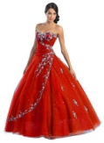](https://www.google.ro/imgres?imgurl=http://weddingsx.org/wp-content/uploads/2013/07/red+wedding+dresses10.jpg&imgrefurl=http://weddingsx.org/red-wedding-dresses.html&docid=eMxNXMK_I2_VQM&tbnid=jHrsllG4ZwFXVM:&w=1102&h=1500&ei=gf6-UsHsFOfB0QWL04CIDg&ved=0CAIQxiAwAA&iact=c)many expensive dresses [](https://www.google.ro/imgres?imgurl=http://b2b.sulekha.com/common/images/visionmediaonline-Printed%20T%20Shirt.jpg&imgrefurl=http://visionmediaonline.b2b.sulekha.com/promotional-t-shirt_product_447918&docid=U0hrYXuO-NO6dM&tbnid=lASFs3zao0vPJM&w=778&h=778&ei=dAC_UrHeIMKS1AWq-oHoDg&ved=0CAgQxiAwBg&iact=c)many t-shirts

[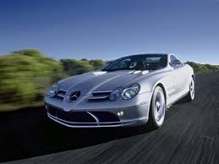](https://www.google.ro/imgres?imgurl=http://www.automotoportal.com/media/images/vijesti/060711010.4_mn.jpg&imgrefurl=http://www.automotoportal.com/article/Top_10_most_expensive_cars_in_the_world&docid=y1kl0e-fJ3InZM&tbnid=6WjRhVzmXj47NM:&w=470&h=352&ei=1P6-Uq3LB-Sm0AXChoHQDg&ved=0CAIQxiAwAA&iact=c)an expensive car [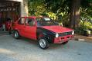](https://www.google.ro/imgres?imgurl=http://carphotos.cardomain.com/ride_images/1/2160/2761/5398880002_large.jpg?v=0&imgrefurl=http://www.cardomain.com/ride/539888/1977-volkswagen-rabbit/page-3/&docid=8sbnkOSmumBKkM&tbnid=3b-tpLNsF6PV1M&w=575&h=385&ei=DQG_UqTiD8mm0AW8pYHQDQ&ved=0CAkQxiAwBw&iact=c) a cheap car

Ex:

A: Has Jane got a cheap car?

B: No, she hasn’t. She’s got an expensive car.

ACTIVITIES

**1. (Pair Work)**. Nice people, nasty people. Take turns to describe someone you know and see if your partner can think of the right adjective.

Use the following list of adjectives:

|  |
| --- |
| Honest modest careless moody positive selfish easy-going rude cheerful hard-working kind polite boring |

Use also words naming family members.

Moody=cu toane/ Easy-going=superficial/ Cheerful=vesel/ Rude=needucat

EX: A: I like my cousin Roger.

B: Why?

A: Because he always sends cards and gives me lots of presents.

B: So you like him because he’s generous.

**2**. (**Pair Work**). Talk to your partner and ask him/her to describe his/her family to you.

**HANDOUT 1/unit 7**

1. Miming. A student will mime a job in the jobs chart in unit 7 and the other students in the group have to guess it. The one who guesses the job goes in front of the class and mimes another job.

**2**. **Match** the adjective to their justifications. Then, use your answer to talk about your relatives or your friends.

|  |  |
| --- | --- |
| **Adjectives** | **Justifications** |
| generous | Wears smart clothes |
| talkative | Always buys family presents |
| energetic | Is very active |
| intelligent | Is liked by everyone |
| bossy | Does well at school |
| rude | Always smiles |
| impatient | Hates waiting for anything |
| popular | Doesn’t like working |
| cheerful | Isn’t polite to other people |
| lazy | Never stops chatting |
| well-dressed | Cares only about himself/herself |
| selfish | Always tells people what to do |

1. We use ***have*/has or *have/has got*** to talk about possessions, families, to describe people and say that we are not feeling well.

Write positive or negative sentences or questions using ***have got*** **/has got** and the words in brackets.

EX: (she/not/brown eyes) She hasn’t got brown eyes.

1. (he/a /flat/in the town centre) ___________________________________________
2. (she/a headache) ____________________________________________
3. (Steve/brown hair?) ____________________________________________
4. (you/a car?) ____________________________________________

**4.** Many people have to study for several years before they take up a profession or job. What have these people studied?

|  |  |
| --- | --- |
| **PROFESSION** | **SUBJECT STUDIED** |
| 1. architect | architecture |
| 2. doctor | medicine |
| 3.lawyer |  |
| 4.artist |  |
| 5.cook |  |
| 6.engineer |  |
| 7.tourist guide |  |
| 8.hairdresser |  |
| 9.journalist |  |
| 10. business man/woman |  |
| 11.actor/actress |  |
| 12.chemist |  |
| 13.biologist |  |
| 14.physicist |  |
| 15.musician |  |

**Note!!!!!** Physicist = fizician / Physician = medic

**5. Work places**. (**PW**) Imagine you have a job in one of these places. Your partner will ask you yes/no questions to discover your job.

A: I work in a hospital.

B: Do you operate on people?

A: No, I’m not a surgeon.

B: Do you clean the floors?

A: No. I’m not a cleaner.

Disneyland an airport an office a school

To retire =a iesi la pensie/ To employ =a angaja

**7. LISTENING.**  You will hear four women talking about their jobs. Listen and complete the information in the table. **(‘Ready for PET’ – Macmillan Heinemann – Unit 3/2, page 22, tapescript page 108)**

|  |  |  |  |  |
| --- | --- | --- | --- | --- |
| **SPEAKER** | **CLOTHES** | **EQUIPMENT** | **PLACE** | **ACTIVITY** |
| 1. |  |  |  |  |
| 2. |  |  |  |  |
| 3. |  |  |  |  |
| 4. |  |  |  |  |

**8.** **LISTENING.**  You will hear a woman talking on the radio about her job. Put a tick in the correct box for each question. **(“Ready for PET” – Macmillan Heinemann – Unit 3/2, page 22, tapescript page 108)**

* 1. WHERE DOES AMANDA USUALLY WORK?
     + 1. In a restaurant
       2. In her own kitchen
       3. In other people’s homes
       4. In recording studios
  2. PEOPLE ARE SATISFIED WITH AMANDA’S SERVICE BECAUSE
     + 1. She provides large meals
       2. She cooks healthy food
       3. She gives people a wide choice
       4. She prepares unusual dishes
  3. AMANDA FINDS HER JOB STRESSFUL IF SHE
     + 1. Has to cook for vegetarians
       2. Has to work in unsuitable places
       3. Doesn’t know how many people to cook for
       4. Doesn’t know when she should serve a meal
  4. WHAT DOES AMANDA ENJOY MOST ABOUT HER JOB?
     + 1. Meeting famous bands
       2. Being her own boss
       3. Working for young people
       4. Earning a lot of money
  5. HOW DOES AMANDA GET TO THE PLACE SHE WHERE WORKS?
     + 1. By car
       2. By bus
       3. By bike
       4. On foot
  6. WHEN SHE GETS HOME IN THE EVENING, AMANDA
     + 1. Writes about cooking
       2. Cooks for her family
       3. Makes a shopping list
       4. Listens to music

**4. What’s my job? (GW)** Listen to your teacher saying some sentences and shout out the job.

EX: Take two of these twice a day.

The brakes need replacing.

Are you ready to order?

Go to the blackboard and write a sentence.

**5**. **Fill in the chart**. How do people look and feel in these situations? To get some help, have a look at the following list of adjectives accompanied by faces.

[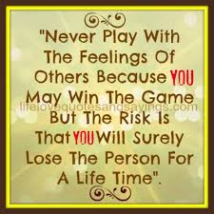](https://www.google.ro/imgres?imgurl=http://www.lifelovequotesandsayings.com/wp-content/uploads/2013/04/Never-play-with-the-feelings...jpg&imgrefurl=http://www.lifelovequotesandsayings.com/2013/04/14/never-play-with-the-feelings-2/&docid=YxK1-QTLlSlGCM&tbnid=hcu2ciKS_ozupM:&w=500&h=500&ei=aRu_Uov5LaS50QWilYDwDQ&ved=0CAIQxiAwAA&iact=c)[](https://www.google.ro/imgres?imgurl=http://1.bp.blogspot.com/-8TUhPyLB6jI/T7B1VQsWILI/AAAAAAAAAHg/dm_nK2R6ZUY/s1600/Feelings-Are-Much-Like-Waves-We-Cant-Stop-Them-From-Coming.png&imgrefurl=http://youareharmony.blogspot.com/2012/05/feelings-are-language-of-your-soul.html&docid=KjEUEF5gkVTwFM&tbnid=cQVw5HEnS786eM:&w=500&h=500&ei=Sxu_UqjnCYGt0QWk7ICgDQ&ved=0CAIQxiAwAA&iact=c)

|  |  |
| --- | --- |
| **SITUATION** | **FEELING** |
| * He wins a marathon |  |
| * They’re playing poker |  |
| * They’re about to take an important exam |  |
| * He has a new sports car |  |
| * He is drunk |  |
| * She falls in the street |  |
| * They will get married |  |
| * He saw a ghost |  |
| * She complains to the manager |  |

[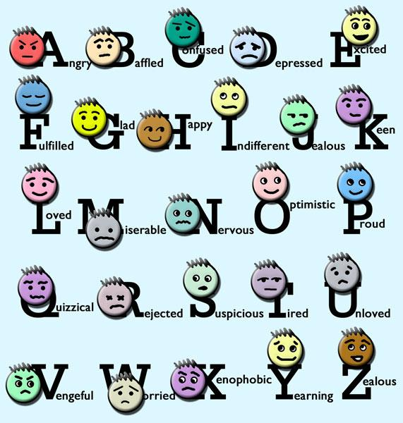](http://www.google.ro/url?sa=i&rct=j&q=&esrc=s&frm=1&source=images&cd=&cad=rja&docid=lXqauX_5SyM6GM&tbnid=0b-yY725Sn-VGM:&ved=0CAUQjRw&url=http://www.sodahead.com/living/do-you-hide-your-feelings/question-1129557/&ei=DB6_UuSfE4rB0QWbsYGYDw&bvm=bv.58187178,d.bGQ&psig=AFQjCNG21xQGM9uOmmEnKtowVllQj35xpg&ust=1388342247536090)

**UNIT 3**

MANY OF THE SAME KIND

Lead –in

1. What is your favourite animal?
2. Have you ever seen exotic animals? Give examples.

[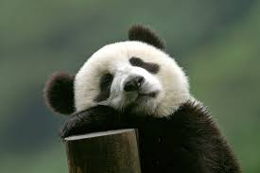](https://www.google.ro/imgres?imgurl=http://www.visitourchina.com/FileUpload/Guide/Picture/20081417017212233.jpg&imgrefurl=http://www.visitourchina.com/wolong/photo/wolong-giant-panda-reserve-centre.html&h=399&w=600&tbnid=ivj7S0Ill4OlFM:&docid=2n94xBRCerTNTM&ei=YPqTVsa7JIHQPPKIm6gL&tbm=isch&ved=0ahUKEwjG69G5t6LKAhUBKA8KHXLEBrUQMwg_KBYwFg)[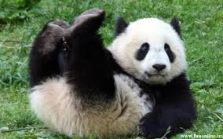](https://www.google.ro/imgres?imgurl=http://www.hapehatelo.com/wp-content/uploads/2015/11/panda_wallpaper_images_inspiring.jpg&imgrefurl=http://www.hapehatelo.com/panda-wallpaper-images-inspiring.html&h=800&w=1280&tbnid=1diFPoXO0lkGcM:&docid=tfmj6IF2VNbCsM&ei=YPqTVsa7JIHQPPKIm6gL&tbm=isch&ved=0ahUKEwjG69G5t6LKAhUBKA8KHXLEBrUQMwhnKD4wPg)[](http://www.google.ro/url?sa=i&rct=j&q=&esrc=s&source=images&cd=&cad=rja&uact=8&ved=0ahUKEwjmo9CdvKLKAhVDchQKHf_3A6kQjRwIBw&url=http://www.funnyjunk.com/funny_pictures/3456884/Panda+bear/&psig=AFQjCNFqGg24ODE1pPURO2CKt3oR8Iw_iQ&ust=1452625223702207)

Reading A

Read the following text and exchange opinions about your favourite animals with your deskmate.

An adult panda bear is 1,5 meters tall. Males weight about 125 kg and females weight about 100 kg. Adults have a length of 160 to 180 cm.

The Giant Panda usually lives for about 20 years in the wild and for about 30 years in captivity. Pandas have black and white fur. They also have black patches around their eyes, over the ears and across its round body.

Pandas are shape like most bears. They are known for their strong teeth which are used to eat bamboo. Pandas must eat 12-38kg every day to meet their energy needs. Sometimes they eat small rodents as well. Pandas in zoos have a diet that usually consists of bamboo, carrots, apples, sugar cane and sweet potatoes.

A panda bear is an endangered animal and does not hibernate. Pandas can have up to 2 babies.

Reading B

Top of Form



# THE FRIENDLY SAIGA

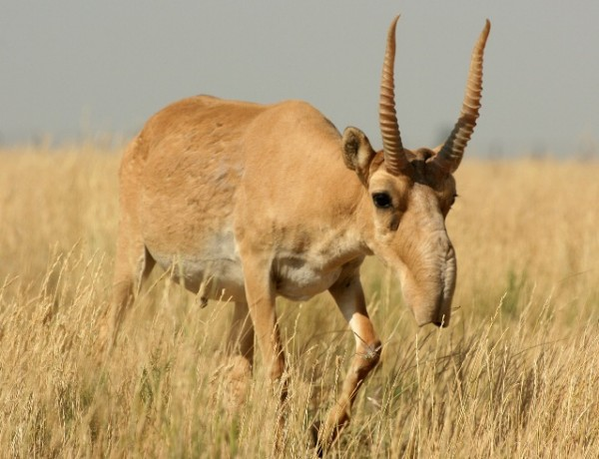

The **Saiga antelope** is a big animal populating the arid steppe regions of Central Asia. Scientists are trying to protect the saiga antelope in Mongolia’s Gobi Desert by using high-tech GPS collars.  
It has the head covered with thick woolly fur, dark yellow on the back. During the summer, the fur is reddish, while during the winter it is thicker and grey-white. The woolly fur layer is made of long hairs, more resistant and shorter ones, soft and fluffy.

It is remarkable by the big, flexible **snout**, with the nostrils oriented downwards with the purpose of having a good sense of smelling, of controlling the body temperature, of heating the air during the winter and filtering the dust during the summer. Its head is extremely big. Its feet are short and slender, the length of the body being 1 to 1,4 meters, the height of 60 to 80 cm, the weight around 29 to 69 kg, while the tail is 6 to 12 cm long. The males are usually bigger than the females.  
Ten thousand years ago, saigas roamed from as far afield as the northern Yukon and Alaska to the United Kingdom. However, today they are found only in Asia because of changes in climate, vegetation, and habitat.  
Poachers, or illegal hunters, kill them for their horns, which are used in medicine. A million of these antelopes lived on the earth just 15 years ago, but only a few thousand survive today.  
These animals live in big herds, preferring to roam around the semi-deserts and open steppes, eating different species of juicy plants. Their capacity of running is very hard, at over 80 km per hour. The breeding season is in November. In the spring of the following year, the females give birth to one or two cubs, who are given milk for approximately a few weeks.

These antelopes live up to 6 to 10 years. The biggest enemies of the antelope are the steppe carnivore animals and the wolves. The youngsters often happen to be the victims of the eagles, foxes and ravens.

The antelope is part of the Bovidae family and it is a very vulnerable species.

Comprehension questions

1. Where do the Saiga antelopes live?
2. Why are they in danger?
3. What is the name for ‘a family’ of Saiga antelopes?

True/False: Write T or F next to the following sentences.

1. The Saiga antelope lives up to 20 years.
2. The antelope is part of the family of cats.
3. These antelopes live in herds.
4. They are killed for their horns.

Vocabulary practice

1. Match the families of animals in Romanian to their correspondents in English. (collective nouns)

|  |  |
| --- | --- |
| O cireada de vaci | A swarm of bees |
| O herghelie de cai | A flight of birds |
| O turma de oi | A school/shoal of fish |
| O haita de lupi | A flock of sheep |
| Un banc de pesti | A pack of wolves |
| Un stol de pasari | A herd of cows |
| Un roi de albine | A herd of horses |

1. Listen to your teacher imitating some animals and guess the sounds made by these animals:
2. Cows a. moo b. scream c. cry d. bark
3. Pigs a. mew b. howl c. grunt d. sing
4. Mice a. squeak b. croak c. coo d. chirp
5. Donkeys a. bray b. neigh c. roar d. chirp
6. Cats a. mew b. grunt c. buzz d. crow
7. Look back at the text and underline all the plural forms of the nouns.

C:\Users\nuti\AppData\Local\Microsoft\Windows\Temporary Internet Files\Content.IE5\IHRKZDSY\MC900442036[1].wmf**Regular plurals (countable)**

Add **–s**: car-cars, girls-girls, pig-pigs

Add **–es** (to nouns ending –s, -ss, -ch, -sh, -x, -o): bus-buses, church-churches, brush-brushes, box-boxes

Nouns ending in a **vowel+y** take **–s** in the plural: boy-boys

Nouns ending in **consonant+y** take **–ies** in the plural: family-families

Nouns ending in **–f** or **–fe** take **–ves** in the plural: thief-thieves

**Irregular plurals**: -oo (sg) turns into –ee (pl): goose-geese

Man-men, woman-women, child-children, deer-deer, sheep-sheep, fish-fish, ox-oxen, mouse-mice, louse-lice

1. Write the words in plural in the correct box:

Bicycle, bus, cherry, knife, man, glass, child, house, apple, box, baby, watch, sheep, city, lady, boy, melon, goose, wolf, calf, wife, dress

|  |  |
| --- | --- |
| -s |  |
| -es |  |
| -ies |  |
| -ves |  |
| irregular |  |

C:\Users\nuti\AppData\Local\Microsoft\Windows\Temporary Internet Files\Content.IE5\EU28NUSC\MC900442036[1].wmfTogether with your teacher, see unit 2 to remember the uncountable nouns.

ACTIVITIES

1. **Group Work**. Imagine that a new animal appears on Earth. In your group, describe this new animal while your group mates try to draw it following your description. Use plural nouns. Show it to the whole class.
2. **Pair Work**. Imagine you are an animal, but don’t tell your partner which one. Continue the sentences and see if your partner can guess what you are. You can use the following animals: bees, hippos, whales, snakes, spiders, owls, bats, ostriches.

* I live in…………// I’m afraid of…………// During the day I………..// I normally live for……
* At night I………..
* I can…….
* I eat……..
* ……….are afraid of me.

1. Project. Imagine you are an animal. Write about your life. Mention where you live, what you eat, what you look like, how long you live for etc.

MY MAGIC BOX

|  |  |  |
| --- | --- | --- |
| |  | | --- | | **Horse around** | | **play roughly** |
| **make a beeline** | **Go straight for something** |
| **let the cat out of the bag** | **Reveal a secret** |
| **smell a rat** | **Begin to suspect something tricky** |
| **straight from the horse's mouth** | **Directly from the original source** |

Jokes

Q: What do you call a pig that does karate?   
A: A pork chop.

What did the dog say to the hot dog bun? "Are you pure bred?"

What is the difference between a cat and a dog? Dogs think, "Humans are good, they feed me and take care of me, so they must be Gods. Cats think, "Humans are good, they feed me and take care of me, so I must be God."

**Handout 1/Unit 3**

1. Write the plural form of the following nouns.
2. [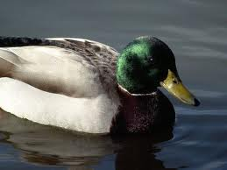](https://www.google.ro/imgres?imgurl=http://images.nationalgeographic.com/wpf/media-live/photos/000/006/cache/mallard-duck_619_600x450.jpg&imgrefurl=http://animals.nationalgeographic.com/animals/birds/mallard-duck/&docid=qjOlyvGj72oQMM&tbnid=NAfvzITnOLNmnM:&w=600&h=450&ei=79THUqPSF4KNtAb8xIDoCA&ved=0CAIQxiAwAA&iact=c) c. [](https://www.google.ro/imgres?imgurl=http://1.bp.blogspot.com/-LX7HGjbGVew/ThQq86vvu_I/AAAAAAAAE8s/p6rFV7iafQc/s1600/Parrot+1.jpg&imgrefurl=http://flowerdreammy.blogspot.com/2011_07_01_archive.html&docid=VTJ5ZP7K9z4koM&tbnid=9BsTMmPqHy-a7M&w=1600&h=1200&ei=gNXHUrTMCtHDtAaP2IGwCw&ved=0CAQQxiAwAg&iact=c) e. [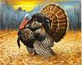](https://www.google.ro/imgres?imgurl=http://dnr.wi.gov/topic/wildlifeHabitat/images/stamp1.jpg&imgrefurl=http://dnr.wi.gov/topic/wildlifehabitat/stamps.html&docid=sINp3e3yUoJnLM&tbnid=KgimxejA4hKHHM&w=3293&h=2613&ei=UNbHUpWjLoHOtAb1roHwAg&ved=0CAQQxiAwAg&iact=c)
3. [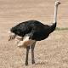](https://www.google.ro/imgres?imgurl=http://www.biodiversityexplorer.org/birds/struthionidae/images/eos01717_327w.jpg&imgrefurl=http://www.biodiversityexplorer.org/birds/struthionidae/struthio_camelus.htm&docid=msBOCo1pemsiyM&tbnid=A011bvbOflf_uM&w=327&h=327&ei=RtXHUunGM4KUtQazs4GACA&ved=0CAMQxiAwAQ&iact=c) d. [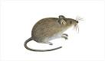](https://www.google.ro/imgres?imgurl=http://www.anticimex.com/Global/Skadedjur/Angriper_mat_textil/anticimex_mus_stor.jpg&imgrefurl=http://www.anticimex.com/sv/se/Privat/Skadedjur/Skadedjurskategorier1/Angriper-mat--textil1/Moss/&docid=5Knc1Buv15v1SM&tbnid=hcf2eM32Wb_m9M&w=515&h=301&ei=uNXHUuKTGMnasgb1x4D4BQ&ved=0CAUQxiAwAw&iact=c) f. [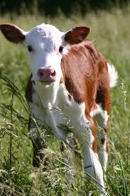](https://www.google.ro/imgres?imgurl=http://www.ansci.wisc.edu/jjp1/ansci_repro/misc/project_websites_fa06/tues06/oocyte/Red%20&%20White%20Calf.jpg&imgrefurl=http://www.ansci.wisc.edu/jjp1/ansci_repro/misc/project_websites_fa06/tues06/oocyte/Untitled-3.htm&docid=_lEWIY9gSS8vPM&tbnid=sdoG0ekwOftmwM:&w=1360&h=2048&ei=x9fHUpSuMIqLswbFpIDwAw&ved=0CAIQxiAwAA&iact=c)

g. [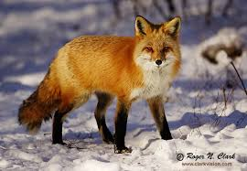](https://www.google.ro/imgres?imgurl=http://www.clarkvision.com/galleries/images.foxes1/web/fox.c01.06.2004.JZ3F3731.clarkvision.com-600.jpg&imgrefurl=http://www.clarkvision.com/galleries/gallery.nature-1/web/fox.c01.06.2004.JZ3F3731.clarkvision.com-600.html&docid=9vr-oh8Frae7-M&tbnid=qyjJWvfDUIbENM:&w=600&h=415&ei=RtjHUtq0IIOktAb2goD4AQ&ved=0CAIQxiAwAA&iact=c)

1. Duck…………………
2. Ostrich (strut)…………………..
3. Parrot……………………………….
4. Mouse………………………………..
5. Turkey……………………………….
6. Calf………………………………………
7. Fox………………………………………

**2**. **Group Work.** Talk with your group mates about animals.

[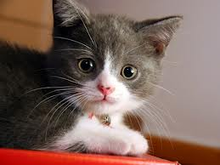](https://www.google.ro/imgres?imgurl=http://scienceblogs.com/gregladen/files/2012/12/Beautifull-cat-cats-14749885-1600-1200-590x442.jpg&imgrefurl=http://scienceblogs.com/gregladen/2012/12/20/the-adventure-of-the-missing-cat/&docid=lKQFAvovaSADqM&tbnid=ITAJT6-MbCzq3M:&w=590&h=442&ei=LdnHUoXGHpHJswb_k4HADA&ved=0CAIQxiAwAA&iact=c) [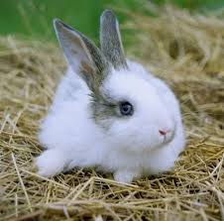](https://www.google.ro/imgres?imgurl=http://petsforlife.com.sg/news/wp-content/uploads/2012/10/Rabbit.jpg&imgrefurl=http://petsforlife.com.sg/news/?p=2762&docid=B9fUB30nEpm9bM&tbnid=D5pb0FKt4EHnpM:&w=400&h=396&ei=5NnHUuP2OcebtAbd9IH4AQ&ved=0CAIQxiAwAA&iact=c) [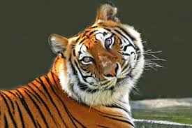](https://www.google.ro/imgres?imgurl=http://bigcathabitat.org/wp-content/uploads/2010/03/Beautiful-Tiger1.jpg&imgrefurl=http://bigcathabitat.org/meet-the-animals/our-tigers/&docid=3H8qLOLj2krP-M&tbnid=pc_HaB4r8gqPhM:&w=500&h=334&ei=mNrHUs7OMsvMswbM0oHoBA&ved=0CAIQxiAwAA&iact=c)

[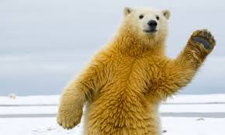](https://www.google.ro/imgres?imgurl=https://static-secure.guim.co.uk/sys-images/Guardian/Pix/pictures/2012/11/14/1352905428522/Polar-Bear-010.jpg&imgrefurl=http://www.theguardian.com/lifeandstyle/series/notes-and-queries+environment/climate-change&docid=o7lpO5Y-GypGlM&tbnid=_Cl6iLGnYGpWbM:&w=620&h=372&ei=XtvHUuyrO4nYswbW_4DYBg&ved=0CAIQxiAwAA&iact=c) [](https://www.google.ro/imgres?imgurl=http://younglearners.eslreading.org/penguins/penguins/emperor_files/BIGmumble%20penguin%20lbox.jpg&imgrefurl=http://younglearners.eslreading.org/penguins/penguins/emperor.html&docid=lznX5SGCYX8BIM&tbnid=IdyZFSm1IF-wIM:&w=345&h=326&ei=H9zHUpi4NoWPtQbd3oHwDA&ved=0CAIQxiAwAA&iact=c)

[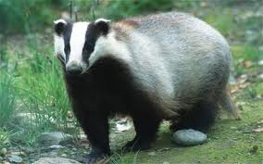](https://www.google.ro/imgres?imgurl=http://i.telegraph.co.uk/multimedia/archive/01876/badger_1876245c.jpg&imgrefurl=http://www.telegraph.co.uk/earth/agriculture/farming/8526748/Badger-cull-may-be-called-off-following-ministers-admission-that-question-mark-hangs-over-the-plan.html&docid=ACzjFlelPhyLgM&tbnid=9pp4fqcIUZZ5eM:&w=460&h=287&ei=9NzHUu-ZG9GKswa8noGICQ&ved=0CAIQxiAwAA&iact=c) badger

Which of these animals is your favorite and why?

**3. Reading practice**. Read the following text and try to place the sentences beneath it in the correct gap.

|  |  |
| --- | --- |
| 1. |  |

Dogs in particular, can make your life more interesting and that is why they are the most popular ones in the world.

|  |  |
| --- | --- |
| 2. |  |

Children love them because they are very playful. Also, they obey commands better than most other animals as they are very obedient. What is more, they never run away from their owners because they are very loyal pets.

|  |  |
| --- | --- |
| 3. |  |

Firstly, they need a lot of space as they are very energetic animals. Secondly, they can cause problems with your neighbours. They can be very noisy sometimes.

|  |  |
| --- | --- |
| 4. |  |

Give your dog a little love and attention and you can have a friend for life.

* + - * 1. However, keeping a dog in the house can be difficult.
        2. A pet can change your life.
        3. In conclusion, I believe that, despite those minor problems, dogs still make the best pets.
        4. Dogs are wonderful pets.

**Handout 2/Unit 3**

1. **Group Work**. Here is some advice about how to look after a small dog. Complete the note with suitable words.

Looking After Your Small Dog

A small………………….needs regular exercise, but………………cannot go………..long walks. You should take your dog…………………..short…………………..two………………..three times…………day.

A dog……………to have……………..regular feeding routine. You ………………feed…………….dog at the same time………………day. But………….must………………..careful not……………….feed it too much. One tin…………..dog food……..day…………….enough. You………………also make sure………….dog always……………enough water…………drink, especially ………………..summer.

When …………………first get……………..dog, take…………….to the vet……a general check-up. After that……………..need……………..take……………….there regularly……………..vaccinations………………further check-ups.

1. Pair Work. One of you is the shop assistant in the pet shop and the other one wants to buy a pet.

Use the guiding ideas to make up a dialogue between the two people.

-what animal makes the best pet (you live in a flat);

-the price of the pet;

-does it need a lot of care?

-does it make noise?

-does it need to be trained?

-does it need much space?

1. What is the baby of each animal called? Match the 2 columns.

|  |  |
| --- | --- |
| Lion | Lamb |
| Sheep | Cub |
| Dog | Calf |
| Cow | Foal |
| Horse | Kid |
| Goat | Puppy |
| Cat | Kitten |

1. At the market. Write the plural forms.

[](https://www.google.ro/imgres?imgurl=http://www.finecooking.com/assets/uploads/posts/5728/ING-grapes-2_sql.jpg&imgrefurl=http://www.finecooking.com/item/5728/grapes&docid=CSsXaRCcLhohxM&tbnid=N6Iy0sUzkFdRFM:&w=370&h=370&ei=oN7HUrX4NMnHtQavh4H4Dw&ved=0CAIQxiAwAA&iact=c)grape -……………. strawberry -……………………..

[](https://www.google.ro/imgres?imgurl=http://www.deshigrub.com/wp-content/uploads/2010/01/tomatoes.jpg&imgrefurl=http://www.deshigrub.com/recipes/from-the-garden/tangy-tomato/&docid=ehMJyygKPz9l7M&tbnid=T9Rm_FsJHYFuoM:&w=300&h=307&ei=fd_HUs3UFYqPtAas94DYBA&ved=0CAIQxiAwAA&iact=c)tomato-…………… peach -…………………………..

lemon -……………. C:\Users\nuti\AppData\Local\Microsoft\Windows\Temporary Internet Files\Content.IE5\P37YI504\MC900383048[1].wmf radish -……………………..

|  |  |  |  |  |  |  |
| --- | --- | --- | --- | --- | --- | --- |
| |  |  |  |  |  |  | | --- | --- | --- | --- | --- | --- | | Top of Form  **http://www.englishexercises.org/makeagame/my_documents/my_pictures/2009/jan/4C8_WildAnimals.gif**  **VOCABULARY: ANIMALS - WRITING**  **INTRODUCTION**   |  | | --- | |  |   **http://www.englishexercises.org/makeagame/my_documents/my_pictures/2009/jan/58Z_image001.jpghttp://www.englishexercises.org/makeagame/my_documents/my_pictures/2009/jan/8A9_image022.jpghttp://www.englishexercises.org/makeagame/my_documents/my_pictures/2009/jan/FA8_image002.jpghttp://www.englishexercises.org/makeagame/my_documents/my_pictures/2009/jan/ED8_image021.jpghttp://www.englishexercises.org/makeagame/my_documents/my_pictures/2009/jan/554_image013.jpghttp://www.englishexercises.org/makeagame/my_documents/my_pictures/2009/jan/136_image023.jpghttp://www.englishexercises.org/makeagame/my_documents/my_pictures/2009/jan/275_image007.jpghttp://www.englishexercises.org/makeagame/my_documents/my_pictures/2009/jan/47A_image018.jpghttp://www.englishexercises.org/makeagame/my_documents/my_pictures/2009/jan/D86_image024.jpghttp://www.englishexercises.org/makeagame/my_documents/my_pictures/2009/jan/E97_image006.jpg**  **EAGLE VULTURE OSTRICH FLAMINGO PARROT TOUCAN HIPPO RHINO BUFFALO ELEPHANT**  **http://www.englishexercises.org/makeagame/my_documents/my_pictures/2009/jan/FZ1_image011.jpghttp://www.englishexercises.org/makeagame/my_documents/my_pictures/2009/jan/21A_image012.jpghttp://www.englishexercises.org/makeagame/my_documents/my_pictures/2009/jan/147_image008.jpghttp://www.englishexercises.org/makeagame/my_documents/my_pictures/2009/jan/B15_image030.jpghttp://www.englishexercises.org/makeagame/my_documents/my_pictures/2009/jan/Z1D_image015.jpghttp://www.englishexercises.org/makeagame/my_documents/my_pictures/2009/jan/E7Z_image026.jpghttp://www.englishexercises.org/makeagame/my_documents/my_pictures/2009/jan/Z72_image009.jpghttp://www.englishexercises.org/makeagame/my_documents/my_pictures/2009/jan/45A_image004.jpghttp://www.englishexercises.org/makeagame/my_documents/my_pictures/2009/jan/EA4_image014.jpghttp://www.englishexercises.org/makeagame/my_documents/my_pictures/2009/jan/3B9_image025.jpghttp://www.englishexercises.org/makeagame/my_documents/my_pictures/2009/jan/64E_image027.jpg**  **LION TIGER LEOPARD CHEETAH PANTHER PUMA GIRAFFE ZEBRA MONKEY GORILLA KANGAROO**  **http://www.englishexercises.org/makeagame/my_documents/my_pictures/2009/jan/6F5_image010.jpghttp://www.englishexercises.org/makeagame/my_documents/my_pictures/2009/jan/4BC_image029.jpghttp://www.englishexercises.org/makeagame/my_documents/my_pictures/2009/jan/F7F_image019.jpghttp://www.englishexercises.org/makeagame/my_documents/my_pictures/2009/jan/12Z_image017.jpghttp://www.englishexercises.org/makeagame/my_documents/my_pictures/2009/jan/A54_image005.jpghttp://www.englishexercises.org/makeagame/my_documents/my_pictures/2009/jan/396_image016.jpghttp://www.englishexercises.org/makeagame/my_documents/my_pictures/2009/jan/D94_image032.jpghttp://www.englishexercises.org/makeagame/my_documents/my_pictures/2009/jan/618_image003.jpghttp://www.englishexercises.org/makeagame/my_documents/my_pictures/2009/jan/F5F_image028.jpghttp://www.englishexercises.org/makeagame/my_documents/my_pictures/2009/jan/2F7_image031.jpghttp://www.englishexercises.org/makeagame/my_documents/my_pictures/2009/jan/E78_image033.jpg**  **KOALA PANDA HYENA PORCUPINE CROCODILE SNAKE TORTOISE CHAMELEON SHARK DOLPHIN WHALE**  **WRITING**  **1. Unscramble the words an write the names of these animals:**  **1. GIRTE http://www.englishexercises.org/makeagame/my_documents/my_pictures/2009/jan/51Z_flecha.png5. YOMENK http://www.englishexercises.org/makeagame/my_documents/my_pictures/2009/jan/51Z_flecha.png**  **2. ILNO http://www.englishexercises.org/makeagame/my_documents/my_pictures/2009/jan/51Z_flecha.png6. AAOKGRNO http://www.englishexercises.org/makeagame/my_documents/my_pictures/2009/jan/51Z_flecha.png**  **3. AEEOHCMNL http://www.englishexercises.org/makeagame/my_documents/my_pictures/2009/jan/51Z_flecha.png7. OIDHPLN http://www.englishexercises.org/makeagame/my_documents/my_pictures/2009/jan/51Z_flecha.png**  **4. YAENH http://www.englishexercises.org/makeagame/my_documents/my_pictures/2009/jan/51Z_flecha.png8. NKSEA http://www.englishexercises.org/makeagame/my_documents/my_pictures/2009/jan/51Z_flecha.png**  **2. Watch de video and write the names of the animals that you can see (you can pause the video while you write).**  **1.** **2.** **3.** **4.** **5.** **6.** **7.** **8.**  **3. Complete the words.**  **a)** VLTR **b)** STIC **c)** BFFL **d)** KL  **e)** LPRD **f)** PNER **g)** CRCDI **h)** RNO  **5. Clasify these animals:**  OSTRICH - PIRANHA - CROCODILE - WHALE - EAGLE - TORTOISE - HIPPO - RHINO - VULTURE - CHAMELEON  BUFFALO - DOLPHIN - FLAMINGO - SHARK - GIRAFFE - PARROT - CHEETAH - SNAKE - KANGAROO - TOUCAN   |  |  |  |  | | --- | --- | --- | --- | | **BIRDS** | **FISH** | **MAMMALS** | **REPTILES** |   Bottom of Form | |

**UNIT 8**

WANNA BE FIT?

Lead-in

1. How often do you practise sport?
2. What is your favourite sport? C:\Program Files\Microsoft Office\MEDIA\CAGCAT10\j0301480.wmf
3. Why do people say practising sport is healthy?

Reading

Kids exercise all the time without even thinking of it. Just being active, like when you run around outside or play kickball at school, is a kind of exercise. What else counts as exercise? Playing sports, dancing, doing push-ups, and even reaching down to touch your toes.

**Exercise Makes Your Heart Happy**

You may know that your [heart](http://kidshealth.org/kid/body/heart_noSW.html) is a muscle. It works hard, pumping blood every day of your life. You can help this important muscle get stronger by doing aerobic exercise.

**Aerobic** means "with air," so aerobic exercise is a kind of activity that requires oxygen. When you breathe, you take in oxygen. Aerobic activity can get your heart pumping, make you [sweaty](http://kidshealth.org/kid/talk/yucky/sweat.html), and quicken your breathing.

When you give your heart this kind of workout on a regular basis, your heart will get even better at its main job — delivering oxygen to all **parts of your body**.

So you want to do some aerobic exercise right now? Try swimming, basketball, ice or roller hockey, jogging , inline skating, soccer, skiing, biking, or rowing. And don't forget that skipping, jumping rope, and playing hopscotch are aerobic activities, too!

**Exercise Strengthens Muscles**

Another kind of exercise can help make your [muscles](http://kidshealth.org/kid/body/muscles_noSW.html) stronger. By using your muscles to do powerful things, you can make them stronger.

Here are some exercises and activities to build strong muscles: push-ups, rowing, running, inline skating, bike riding.

**Exercise Makes You Flexible**

* Can you touch your toes easily without yelling ouch? Most kids are pretty flexible, which means that they can bend and stretch their bodies without much trouble. It's easy to find things to do for good flexibility: tumbling and gymnastics, dancing, especially ballet, martial arts, simple stretches, such as touching your toes or side stretches.

**Exercise Keeps the Balance**

Food gives your body fuel in the form of calories, which are a kind of energy. Your body needs a certain amount of calories every day just to function, breathe, walk around, and do all the basic stuff. But if you're active, your body needs an extra measure of calories or energy. If you're not very active, your body won't need as many calories.

Vocabulary practice based on the text

**1**. What is the main idea of the text?

**2.** Look back at the text. Underline all the sports in the text. Place these sports and the ones in the list below in the correct box.

List of sports: sailing, football, handball, fishing, horse riding, cycling, table tennis, weightlifting, tennis, canoeing, basketball, badminton, athletics.

|  |  |  |  |  |
| --- | --- | --- | --- | --- |
| **Team sport** | **Individual sport** | **With a ball** | **Indoors** | **Outdoors** |
|  |  |  |  |  |
|  |  |  |  |  |
|  |  |  |  |  |
|  |  |  |  |  |
|  |  |  |  |  |

**3.** Using the same sports, work in pairs and decide on the correct verb that goes with each sport.

**do**

**go**

**play**

**4.** Do you remember the reading text telling you about the benefits of sport regarding keeping your body healthy? Work with your partner and **cut out** the part of the body. Then **stick** them on your partner’ s body.

HEAD C:\Users\nuti\AppData\Local\Microsoft\Windows\Temporary Internet Files\Content.IE5\IHRKZDSY\MC900238192[1].wmfEAR

C:\Users\nuti\AppData\Local\Microsoft\Windows\Temporary Internet Files\Content.IE5\P37YI504\MC900413506[1].wmfARM HAND

FOREHEAD 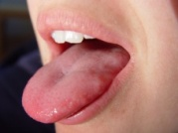TONGUE

LIPS C:\Users\nuti\AppData\Local\Microsoft\Windows\Temporary Internet Files\Content.IE5\P37YI504\dglxasset[1].aspxHAIR

 EYE 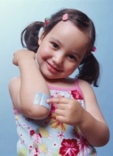 ELBOW

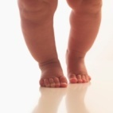 LEG  FOOT

C:\Users\nuti\AppData\Local\Microsoft\Windows\Temporary Internet Files\Content.IE5\EU28NUSC\MC900232049[1].wmfKNEE 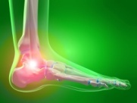 ANKLE

FINGER 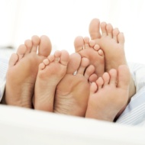 TOE

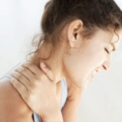 NECK C:\Users\nuti\AppData\Local\Microsoft\Windows\Temporary Internet Files\Content.IE5\IHRKZDSY\dglxasset[1].aspx HEEL  THUMB

C:\Users\nuti\AppData\Local\Microsoft\Windows\Temporary Internet Files\Content.IE5\IHRKZDSY\MC900028142[1].wmf NOSE 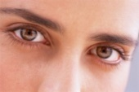 EYEBROWS C:\Users\nuti\AppData\Local\Microsoft\Windows\Temporary Internet Files\Content.IE5\P37YI504\MC900012912[1].wmf TEETH

C:\Users\nuti\AppData\Local\Microsoft\Windows\Temporary Internet Files\Content.IE5\IHRKZDSY\MC900097891[1].wmf CHIN

Grammar practice

**CAN** for ability (mental and physical abilities)-modal verb

I, You, He, She, It, We, You, They **CAN -** affirmative

I, You, He, She, It, We, You, They **CANNOT (CAN’T) -** negative

**CAN** I, You, He, She, It, We, You, They? – interrogative

**CAN** to ask somebody to do something: Can you open the door, please?

**CAN** to ask for something: Can I have a piece of cake,please?

**CAN** to ask for permission: Can we play on the computer, please?

1. Ask questions using the modal verb CAN and give positive or negative answers:

**EX:** Elephants fly.

Can elephants fly?

No, they can’t.

1. Penguins swim.

……………………………………………..

……………………………………………..

1. Horses swim.

……………………………………………..

…………………………………………….

1. Lions climb trees.

………………………………………………..

………………………………………………..

1. **Pair Work**. Ask your partner what she/he can do.

**PRESENT CONTINUOUS** (actions happening right now)

**Form**: verb TO BE + vb-ing

I am, you are, she is, he is, we are, you are, they are + washing the dishes. – affirmative

Am I, are you, is she, is he, are we, are you, are they + washing the dishes? – interrogative

I am, you are, she is, he is, we are, you are, they are NOT + washing the dishes. – negative

1. Look around the classroom and tell the class what different students are doing right now.
2. Look at the pictures and tell us what people are doing.

Picture A Picture B

[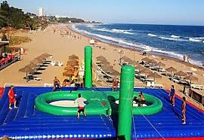](http://www.google.ro/imgres?start=279&sa=X&biw=1280&bih=631&tbm=isch&tbnid=0QcFqkX1S6fb_M:&imgrefurl=http://icantbelieveit.org/2013/06/10-most-unusual-sports-in-world.html&docid=OH0Pje8ywCsZ6M&imgurl=http://3.bp.blogspot.com/-sTKQuDlmynI/UcGCeTZf5GI/AAAAAAAAPoo/9jplMMaqMog/s1600/Bossaball-court.jpg,qresize=500,P2C345.pagespeed.ce.UslA1hKYJr.jpg&w=500&h=345&ei=kwrIUq7-JYjOygPpxYC4Aw&zoom=1&ved=1t:3588,r:97,s:200,i:295&iact=rc&page=15&tbnh=186&tbnw=253&ndsp=22&tx=111&ty=118) [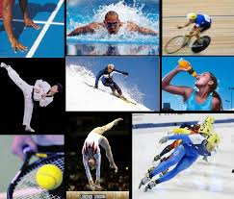](http://www.google.ro/imgres?sa=X&biw=1280&bih=631&tbm=isch&tbnid=NXyuhimAlXgmAM:&imgrefurl=http://scorzacomenius.altervista.org/?m=201004&docid=9yGtdJDbNY_-AM&imgurl=http://www.labachecadabruzzo.it/abruzzo_eventi/images/stories/sport.jpg&w=966&h=824&ei=QgrIUsS8EuP-ygP17oLIBA&zoom=1&ved=1t:3588,r:90,s:0,i:359&iact=rc&page=5&tbnh=174&tbnw=158&start=73&ndsp=20&tx=82&ty=99)

**Handout 1 – Present continuous, CAN/Unit 8**

**!!!!!!** ( the intermediate group will get extra handouts: Grammar Way 3 and 4; Headway Intermediate, page 3)

1. Write questions and negations as in the example.

**EX**: He is riding a bicycle.

Is he riding a bike?

No, he is not riding a bike.

1. They are listening to the radio.

………………………………………………?

………………………………………………

1. You are dancing.

………………………………………………?

……………………………………………….

1. I am running.

……………………………………………….?

………………………………………………..

1. Make up questions and answers as in the example.

**EX:** (Jim/wash his car)

Is Jim washing his car?

Yes, he is.

1. (the children/knit) to knit=a tricota
2. (dogs/chase a cat)
3. (Grandmother/write a letter)
4. Ask for things in each place. Choose from the expressions below.

* a train station (can/could I…………., please?)
* a restaurant (can I…….., please?)

*Expressions:*

|  |
| --- |
| have a town plan have some fish and chips have two melons  have a ticket to London |

1. Ask people to do things. Use the phrases below.

* You are lost in London. (could you……., please?)
* You are hungry. You are very tired. (can you………., please?)

*Phrases:*

|  |
| --- |
| tell me the time tell me the way to Buckingham Palace make me a sandwich buy me a magazine |

1. Ask for permission. Use the words in the list.

* You want to write down a phone number. (can I…………?)
* You want to watch a programme. (can I…………, please?)

*List of words:*

|  |
| --- |
| borrow your pen close the window turn on the TV use your dictionary |

6. Make sentences which are true using can or can’t.

1.An artist /paint pictures. ***An artist can paint pictures.***

2.A cat / fly. ***A cat can’t fly.***

3.A monkey/climb trees.______________________________________________________________________

4.A leopard /run fast._________________________________________________________________________

5.A pilot/fly an aeroplane._____________________________________________________________________

6.A dog /talk._______________________________________________________________________________

7.A fish /walk.______________________________________________________________________________ 8.An elephant /fly.___________________________________________________________________________ 9.A baker / make bread_______________________________________________________________________ 10.A hamster / ride a bicycle.__________________________________________________________________

7. Put a tick (ѵ) for each thing you can do and a cross (x) for each thin you can’t do. Then, ask your partner what he/she can or can’t do. Finally, tell the class what you and your friend can and can’t do as in the example.

e.g*. I can speak English, cook spaghetti and draw but I can’t play a musical instrument, drive a car or type. My friend Maria…..*

|  |  |  |
| --- | --- | --- |
|  | I | My friend |
| Play a musical instrument |  |  |
| Speak Enghlish |  |  |
| Cook spaghetti |  |  |
| Drive a car |  |  |
| Draw |  |  |
| tye |  |  |

1. For each of the situation below, fill in the gaps with Can you or Can I and a verb from the list.

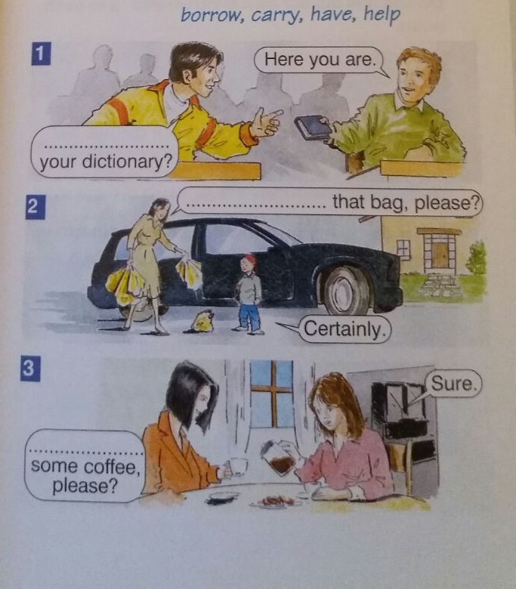

9. Jim Lawton is a stunt man. He can do many dangerous thing, but there are some simple things that he can’t d. Look at the pictures and in pairs ask and answer questions as in the example.

*e.g.SA: Can he drive a racing car?*

*SB: Yes, he can*

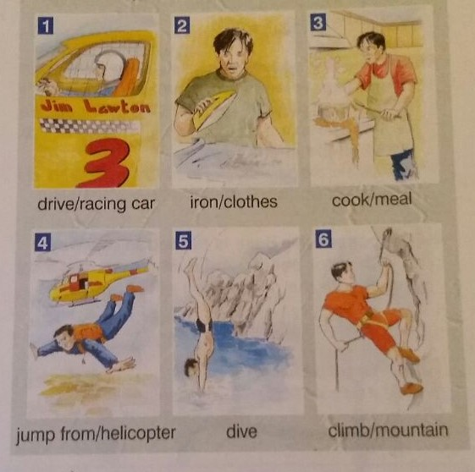

10.Use the verb in brackets to complete the sentences:

1. I am living (live) in London now even if I usually live in Bucharest.

2. I ___________________________ (go) shopping now. Do you need anything from the supermarket?

3.What ___________________(you/do) here at this time of the night?

4.Whach out! You baby sister __________________________ (jump) in her bed!

5.They ____________________________ (spend) their holidays in the countryside this year.

6. Why _____________________________ (you/stay) here alone while all the others ________________(dance) in the living room?

7.Listen! Sue __________________________(speak) Greek!

8.What uniform ______________________(that man/wear) is navy or military?

11.It’s morning. The people below are doing different things. Find out and fill in the blanks!

|  |  |  |  |
| --- | --- | --- | --- |
| Flat | mother | father | Chidren |
| 11 | Choose a dress | Make a phone call | Sleep in their room |
| 15 | Make sandwiches | Take a shower | Have breakfast in the kitchen |
| 21 | Call a taxi for everybody |  |  |
| 24 | Wait for the bus | Stay sick at home | Meet their friends |

a.The mother at no.11 ***is choosing a ddress*** now while the children _______________________________________________________________________________________

b.At no.15 the mother __________________________ for the children wh_________________________________

c.Thefather at no.24 is not going anywhere because he __________________________________

d.At no.21 the mother____________________________________________________________________________

e.The children at no.24 ___________________________________________________ while their mother_____________________________________

f.At no.11 the father _____________________________________________. In the living room while the father at no.15 _________________________________in the bathroom.

12.Now, answer the questions about the people at exercise 11!

1.Is any of these people making sandwiches

Yes, the mother at no.15 is.

2.Are these people having breakfast?

3.Is there anybody calling a taxi?

4.What do you know about the people at no. 24?

5.Is any of these people choosing clothes?

6.Is there anybody not going anywhere?

7.Who is waiting for the bus?

8.What are the children at no.11 doing now?

9.Ia any of these people making any phone call?

**Handout 2 – Sports, Parts of the Body/Unit 8**

1. Can you guess the sports?

Individual sport, 2 players, ball, racket, net, court

Individual sport, boots, skis, slope



11 players in each team, pitch, ball, goal,

1. Fill in the blanks with the right verb: DO, PLAY, GO.
2. I love to……………………………….badminton.
3. Every winter, my family and I………………………………..skiing in the mountains.
4. I………………………..aerobics three times a week.
5. In their spare time, they…………………………soccer with their friends.
6. I usually…………………..jogging in the morning.
7. All little girls want to……………………………..gymnastics.
8. **Parts of the Body** (http://www.englishexercises.org/makeagame/viewgame.asp?id=659)

**Label the pictures**:

|  |  |  |  |  |  |
| --- | --- | --- | --- | --- | --- |
| http://www.englishexercises.org/makeagame/my_documents/my_pictures/2008/oct/76F_eyes.jpg | http://www.englishexercises.org/makeagame/my_documents/my_pictures/2008/oct/E4Z_fingers_.jpg | http://www.englishexercises.org/makeagame/my_documents/my_pictures/2008/oct/A77_ears.jpg | http://www.englishexercises.org/makeagame/my_documents/my_pictures/2008/oct/941_hand2_thumb.jpg | http://www.englishexercises.org/makeagame/my_documents/my_pictures/2008/oct/DZ4_hair2_thumb.jpg | http://www.englishexercises.org/makeagame/my_documents/my_pictures/2008/oct/C9F_mouth.jpg |

|  |  |  |  |  |  |
| --- | --- | --- | --- | --- | --- |
| http://www.englishexercises.org/makeagame/my_documents/my_pictures/2008/oct/AFC_foot_thumb.jpg | http://www.englishexercises.org/makeagame/my_documents/my_pictures/2008/oct/DA7_elbow_thumb.jpg | http://www.englishexercises.org/makeagame/my_documents/my_pictures/2008/oct/D7D_back_thumb.jpg | http://www.englishexercises.org/makeagame/my_documents/my_pictures/2008/oct/BE6_arm_thumb.jpg | http://www.englishexercises.org/makeagame/my_documents/my_pictures/2008/oct/ED5_leg_thumb.jpg | http://www.englishexercises.org/makeagame/my_documents/my_pictures/2008/oct/2D8_nose2_100.jpg |
| http://www.englishexercises.org/makeagame/my_documents/my_pictures/2008/oct/579_neck2_thumb.jpg | http://www.englishexercises.org/makeagame/my_documents/my_pictures/2008/oct/BB2_toes_thumb.jpg | http://www.englishexercises.org/makeagame/my_documents/my_pictures/2008/oct/769_shoulders_thumb.jpg | http://www.englishexercises.org/makeagame/my_documents/my_pictures/2008/oct/Z51_knee_thumb.jpg | http://www.englishexercises.org/makeagame/my_documents/my_pictures/2008/oct/B5Z_teeth2_thumb.jpg | http://www.englishexercises.org/makeagame/my_documents/my_pictures/2008/oct/F13_images.jpg |

**How many parts of the body do we have?** **one / two / ten**

* head fingers eyes mouth nose knees ears
* shoulders legs arms neck toes feet back

|  |  |  |
| --- | --- | --- |
|  |  |  |

|  |
| --- |
|  |

**UNIT 9**

MEMORIES

Lead in

‘The Translator’ – drama activity (improvisation)

Warm up

**1**. Do you like going shopping? Do you like shopping in small shops or in large centres?

**2.** What’s the item/product that you buy almost every time you go shopping?

**3**. Who decides on going shopping you or your parents?

**Reading**

* 1. **Read the text.**

[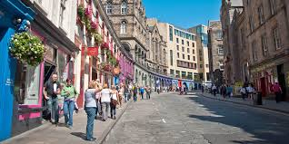](https://www.google.ro/imgres?imgurl=http://www.visitscotland.com/cms-images/2x1/regions/edinburgh/shopping-edinburgh&imgrefurl=http://www.visitscotland.com/see-do/shopping/edinburgh-lothians/&docid=aapO-BzeZitcpM&tbnid=irlJsYueG4ZSEM:&w=740&h=370&ei=3W-gVOykG4W5OI3MgTA&ved=0CAIQxiAwAA&iact=c)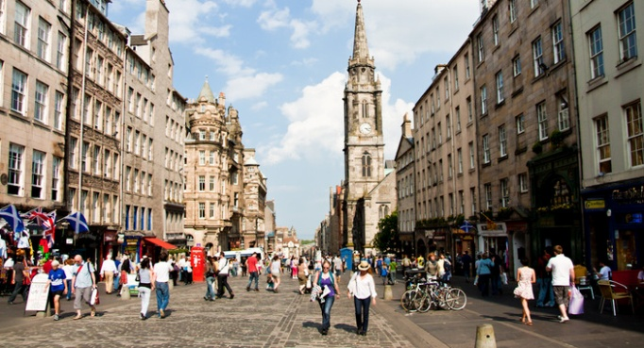**Royal Mile, Edinburgh**

Last Saturday, in wintry weather, I visited my uncle Rupert. He was born in Edinburgh, Scotland, but he got married here in Berlin to my aunt Karin. I knew he always wanted to see photos of his dearest home city, even if he still travels a lot. However, his last visit to Edinburgh was 20 years ago.

I just came back from my trip to Edinburgh. I was there on business. I brought my uncle some pictures of this town he loves best. He was so impressed when he saw the road that leads from the Castle to the Parliament, the Royal Mile.

‘My dear, do you know that this street was full of lovely shops. For example, here Mr. Thompson owned a **barber** shop where I used to go everytime I wanted to look attractive for my new girl friend’, said *Rupert* laughing.

‘Now there’s a **baker’s** in that very spot’, *I* told him.

*Rupert:* ‘What shop is there now next to the church? When I last went to the place there was **a bookshop** there. One of my best friends sold flowers at the **florist’s**. Is this one still there?’

*Me:* ‘No, but can you see the pink shop on the left? It’s Mrs. Johnson’s **dry cleaner’s**. During my stay in Edinburgh I took my dirty clothes there. Uncle Rupert, your glasses seem to be very expensive. It says they’re MAXEYE. Are they THE MaxEye?’

*Rupert:* ‘Oh, yes. The **optician’s** I bought them from was right where that man with the bike is in the photo’.

*Me:* ‘It’s still there. Max Pearson’s Optics’.

We talked a lot till almost midnight. I left him promising that I would be back as soon as I could.

(original text-written by teacher Andreea Ionel)

Vocabulary

* 1. Identify all the shops in the text and say what we can buy/do at these shops.
  2. Study this list of shops.

Florist’s=florarie

Butcher’s=macelarie

Toy shop=magazine de jucarii

Bookshop=librarie

Shoe shop=magazin de pantofi

Newsagent’s=magazine de ziare si reviste

Tobacconist’s=tutngerie

Chemist’s=farmacie

Grocer’s=bacanie

Greengrocer’s=magazine de legume-fructe

Stationery/Stationer’s=papetarie

Sweet shop=magazine de dulciuri

Dry-cleaner’s=spalatorie

Fishmonger’s=magazin de peste

Furniture shop=magazin de mobila

* 1. Look at the pictures showing things we can buy. Write the appropriate in each box.
     1. doll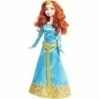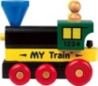toy train
     2. medicine
     3. books
     4. flowers
     5. newspapers, magazines
     6. 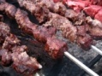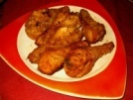 meat
     7. 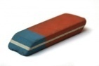

Pen, paper, rulers

* 1. Dialogue. Ask your partner where you can buy the following things. Use the names of shops in exercise 3.

Ex. Where can I buy an eraser, please?

At the stationer’s

***Shopping List***

-2 comics, 1magazine - shoes

-1 kg of flour - 1 kg of beef

-3 pens - painkillers

-2 frozen chicken - a chair and a cupboard

-1 book

-2 kg of fish

* 1. What tense is used in the text? Why? Write down all the verbs in that tense that you can find.

C:\Users\nuti\AppData\Local\Microsoft\Windows\Temporary Internet Files\Content.IE5\EU28NUSC\MC900442036[1].wmfGRAMMAR

We use the Past Simple to talk about things which happened in the past, often with adverbs like **ago**, **last**, and expressions like **last year**, **three months ago** or a sentence like **‘when I was young’** to give particular times .

Many Past Tense verbs end in **–ed,** they are **regular verbs:** walk-walked; play-played; dance-danced

Some change their spelling before –ed: cry-cried

A lot of verbs have **irregular forms** in the Past Tense: come-came; have-had; do-did; see-saw; speak-spoke; take-took; make-made; go-went; hear-heard, etc

The interrogative and negative of the Past Simple are formed with the help of **did** +the short infinitive:

**Did** you/he/she/it/we/they visit their friends?

I/you/he/she/it/we/they **didn’t** eat the cake.

13.Fill in the blanks with the following words:

Cleaned watched didn’t take

Washed went

Tried didn’t see

a. Last Thursday we cleaned the whole house.

b. Zina______________________________ her medicine yesterday and now she is feeling sick.

c. We _______________________________ to convince him that he was wrong, but he didn’t believe us.

d. I _________________________________ you at school last morning. Where were you?

e. Louise ____________________________ the dishes and then started to cook again.

f. Their little brother _____________________________ cartoons all day yesterday.

g. We ___________________________ to the seaside together two years ago and we had a lot of fun.

14. Use the verbs in brackets to complete the sentences:

1.I **lived** (live) in Paris last year.

2.You _________________ (cook) a very tasty meal yesterday.

3.He __________________ (arrive) home earlier than the others expected.

4.They ___________________ (watch) an action movie at the Mall last Sunday.

5.Mum __________________________ (show) us how to use the vacuum cleaner yesterday.

6. Maggy’s father ________________________ (drive) the whole way to the mountains last May.

7.We ________________________ (study) French and German when we were young.

8.Mum _________________________ (smile) at me when she saw me in the morning.

9.Little Meg first ________________________ (brush) her teeth and then she went to bed.

10.Ronny ______________________ (walk) his dog in the rain yesterday.

11.I ______________________ (try) to solve the Math problem, but it was too difficult for me.

12.He ____________________(travel) in many countries in his childhood.

15.Put the words in the right order:

1.my/do/last evening/I/homework /didn’t

***I didn’t do my homework last evening***.

2.their/us/to/party/last/invited/They/Sunday/

3.we/happy/that/took/We/good/grades/were/

4.our classroom /know/about/you/the missing wallet/in/the truth /Did?

5.didn’t/yesterday/her/sandwiches/eat/Jen

6.results/my/upset/because of/last/My tennis coach/was/

7.studet/came/Two/last/year/new/in our class/

8.when/I/saw/upset/you/Why/in the schoolyard/were/you/yesterday/?

9.the/in your class/Was/Roxane/ at the last school/best?

10.you/ot/Where/my/did/earrings/?

___________________________________________________________________________________________

UNIT 10

THE FOUR CORNERS OF THE EARTH

Lead in

‘I am…’ – drama activity (emotions)

Warm up

1. What stories about the environment are in the news at the moment?
2. Make 2 lists of things we *should do* and things we *shouldn’t do* if we want to protect the environment.

Reading

Read the following text.

Just like you, the planet Earth needs to stay in good health in order to function at its best. Without good health, the Earth would not be able to do those things we need most: grow plants and animals, give us clean air and water, provide beautiful places for us to visit and all the other things we take for granted each day.

The current state of our planet environment is due to a long process of degradation which, in turn, owes to both natural disasters and those produced by humans. Sometimes humans can cause natural disasters, such as floods (because of deforestation).

Some **natural disasters** are: thunderstorms, [volcano eruption](http://www.basicplanet.com/volcano-eruption/)s, [heat wave](http://www.basicplanet.com/heat-wave/)s, [hurricane](http://www.basicplanet.com/hurricane/)s, [drought](http://www.basicplanet.com/drought/)s, [tornado](http://www.basicplanet.com/tornado/)es, [tsunami](http://www.basicplanet.com/tsunami/)s, [hail](http://www.basicplanet.com/hail/), [wildfire](http://www.basicplanet.com/wildfire/)s, asteroids, earthquakes, avalanches, floods, [landslide](http://www.basicplanet.com/landslide/)s, solar flares

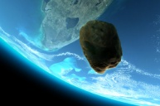 asteroids 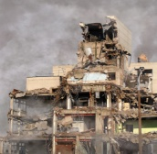 earthquakes 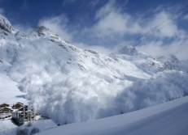 avalanches

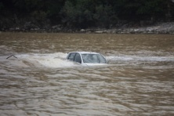 floods 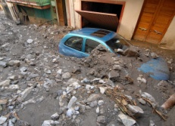 [landslide](http://www.basicplanet.com/landslide/)s 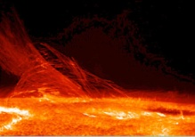 solar flares

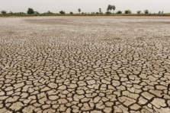 drought 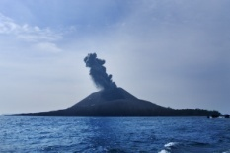 volcano eruption

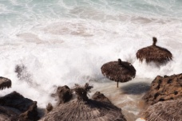 tsunami 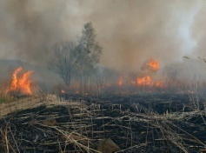 wildfire

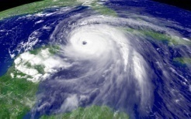 hurricane

Let’s not blame it all on nature. There are **disasters caused by humans**, but we are so familiarized with them that we don’t even realize that the catastrophes that take place have a human ‘origin’. Even if industry nowadays is extremely developed there isn’t yet a secure way of throwing away the wastes. People throw wastes in waters or bury them underground which leads to infesting the earth with toxic products. So there comes **pollution**. Pollution destroys the ozone layer so the air we breathe is not clean and pure anymore. Moreover, without the ozone layer the sun burns us and destroys our crops, melts waters and the air gets hotter = greenhouse effect = global warming. As the atmosphere warms, there will be more intense rain and as a result we will see even more landslides. There are often other human activities - deforestation, growing crops on vertical land, building houses on in danger sites, irrigating in the wrong place, building roads or dams for which they had to dig extensively and very deep - that cause landslides.

|  |
| --- |
|  |
|  |

To provide = a furniza, a aproviziona

To take for granted = a lua de bun, ca si cand ti s-ar cuveni

State = stare

To owe = a datora

Deforestation = despadurire

Landslides = alunecari de teren

Drought = seceta

Wildfire = incendiu de vegetatie

Solar flares = explozii solare

To blame something on = a da vina pe ceva

Nowadays = in zilele noastre

To throw away = a arunca la gunoi

Wastes = reziduuri

Ozone layer = strat de ozon

Site = santier, loc de construit

To bury = a ingropa

Extensively = mult, considerabil

Comprehension questions

1. Why do we need to keep our planet Earth in good health?
2. Who is responsible for the way our planet looks like nowadays?
3. Name some natural disasters.
4. What do you think is the difference between natural disasters and those caused by people?
5. What happens if we don’t throw away wastes in the correct places?

**Activity 1 – writing, GW**

This is a very short list of some natural disasters. In groups of 4, choose one and write a petition (letter) to the Government telling them that you care a lot about that problem and you want them to help you with your

* Too much trash, deforestation, global warming, famine (foamete), wildfires, landslides,

epidemics, air pollution and acid rain, water pollution

**Handout 1/Unit 10 - PW**

Match the natural disasters with their definitions. Work in pairs.

|  |  |
| --- | --- |
| **Disaster** | **Definition** |
| Asteroids | This word is used especially of storms in the western Atlantic. It is a violent storm with very strong winds. It is called typhoon especially in Asia |
| **Avalanches** | A ……… is a long period of time, stretching months or even years in which time land has a cut in the amount of water. Crops die and people may starve to death |
| Earthquakes | When a forest catches fire. There are ………….. on almost every continent but Antarctica. They are mostly found in Australia. If the weather is dry and if there has been a recent drought then it can all contribute to a ………… starting |
| **Floods** | A ……….. is mountain with a hole in the top and when it erupts hot gases and lava are forced out into the air and onto the land around it |
| **Landslides** | Any time a river, lake, or other body of water overflows its banks, it creates ……... They are caused by heavy rains, melting snow and ice, changing the course of the rivers |
| **Solar Flares** | An …………. is simply a quick flow of snow down a slope. At the mountains, snow slides are one of the most dangerous natural disasters to life because they are able to destroy almost anything in its way with an immense amount of snow at high speeds. An ……………. can contain ice, rocks, trees besides air and snow. |
| Drought | ………… live in space and orbit the earth and solar system every single day. ……….. are actually very small planets. Ceres, the first ever ……… to be discovered is the biggest one by far because it reaches an estimated 975 kilometres |
| Volcano eruption | They are sudden release of energy in the earth’s crust causing movement. This gigantic release of energy creates what are known as ‘seismic waves’. These waves cause the one of the most terrifying and destructive acts of nature on the planet. ……………. can cause many **other natural disasters:** tsunami, fires, landslides and avalanches, floods, human and animal death |
| Wildfires | …………… are heavy falls of earth and rocks down the side of a mountain. They are caused by the glaciers that melt, volcano eruptions, earthquakes |
| Hurricanes | They are ………explosions. ……… are what cause the aurora borealis and the aurora australis. The stronger ones can destroy communications and electrical systems |

Words:

Release = degajare, descarcare

Flow = curgere, flux

Snow slides = alunecari de zapada

Besides = in plus fata de, pe langa

Amount = cantitate

Overflow = a iesi din matca, a se revarsa

To stretch = a se intinde

Crops = recolta

Starve to death = a muri de foame

**LISTENING - "Oxford Word Skills"**

**Use the handout given the teacher (pages 44-46)**

**What do you think?**

1. How ‘green’ are you? What have you done to be more friendly to the environment?
2. How could you become more ‘green’?

**MY BOX OF IDIOMS**

|  |  |
| --- | --- |
| **IDIOM** | **MEANING** |
| Still waters run deep | Quiet people are dangerous |
| Clear as mud | Unclear and confusing |
| Four corners of the world | Smth that goes to…….it goes everywhere |
| Ride with the tide | Accept the majority decision |

**OVERVIEW OF THE UNITS**

**UNIT 1- CELEBRITIES AT WORK**

**VOCABULARY:**

* Countries and nationalities (Where are you from?, Where do you come from?, What nationality are you?);
* Celebrities; your favourite famous person;
* Meeting people – ways of greeting people and introducing someone;

**GRAMMAR :**

* Likes and dislikes (like, hate etc +vb+ing)
* The present simple tense

**ACTIVITIES :**

* ‘The Olympic Torch’ (nationalities, capital cities)
* ‘Loan Words’ (countries and languages)

**MY MAGIC BOX** – idioms related to nationalities

**THREE HANDOUTS**

**UNIT 3- EXCUSE ME, WHERE IS THE PACK OF WOLVES?**

**VOCABULARY**

* Animals – sounds made by animals:

**GRAMMAR**

* Plurals – collective nouns, regular nouns, irregular nouns

**ACTIVITIES**

* A New Animal! - GW
* What Animal are You? – PW
* Imagine you are an animal – Pj. W.

**MY MAGIC BOX** – idioms related to animals

**UNIT 5 - HOORAY!! WE ARE GUESTS AT THE INTERNATIONAL FEAST!!**

**VOCABULARY**

* Saying ‘Good Appetite!’ in different languages;
* Types of food around the world;
* Kitchen verbs;

**GRAMMAR**

* Uncountable nouns;
* Quantifiers;

**ACTIVITIES**

* ‘Odd one out’;
* ‘Edible or Inedible’;

**MY MAGIC BOX** – idioms related to food

**TWO HANDOUTS**

**UNIT 7 – WE WORK TOGETHER AS A FAMILY**

**VOCABULARY**

* Family members;
* Describing people (appearance and character);
* Jobs;

**GRAMMAR**

* Have/has got;

**ACTIVITIES**

* ‘Nice people, nasty people’ – PW;
* Dialogues about students’ families – PW

**ONE HANDOUT**

**UNIT 8 – FUNNY AND SPORTY!!**

**VOCABULARY**

* Sports and free time activities;
* Body parts;

**GRAMMAR**

* Modal verbs: **CAN**
* The Present Continuous Tense

**TWO HANDOUTS**